Olerup SSP®

PHOTO DOCUMENT

Olerup SSP® HLA-A-B-DR Combi Tray

Prod. No: 101.701-24/24u
101.701-06/06u
Lot No: 63S
Expiry Date: 2016-March-01

Name:________________Sample ID:_______________

DNA Extract Date:_________ Conc.(ng/ul):_________

Test Date: _________Review Date:_______________

Tested By: _________Reviewed By:_______________

Interpretation:_________________________________

Specificities and sizes of the PCR products of the 24 primer mixes used for HLA-A low resolution SSP typing.
Primer Mix | Size of spec. PCR product¹ | Size of control band² | HLA-A  serology³ | Amplified HLA-A alleles^{4,5}
1^{6,7} | 120 bp, 145bp,  225 bp | 800 bp | A1, A36 | *01:01:01:01-01:04N, 01:06-01:33, 01:35-01:130, 03:18, 03:135, 11:94, 11:112, 36:01-36:05
2⁷ | 175 bp,  215 bp,  255 bp,  365 bp,  415 bp | 800 bp | A2, A19,  A28, A203, A210 | *02:01:01:01-02:01:15, 02:01:17-02:01:19, 02:01:21-02:01:81, 02:01:83-02:22:02, 02:24:01-02:35:01, 02:35:03-02:47, 02:49-02:77, 02:78^{w}, 02:79:01-02:97:02, 02:99, 02:101:01-02:128, 02:130-02:414, 02:416-02:417
3⁸ | 205 bp,  235 bp | 1070 bp | A1, A3, A11, A32, A34, A36 | *01:12, 01:19, 01:21, 01:126, 02:338, 03:01:01:01-03:17:02, 03:19-03:74, 03:76-03:94, 03:96-03:134, 03:136-03:166, 11:25, 11:60, 11:130, 24:92, 32:04, 34:02:01-34:04, 34:07-34:10N, 36:02
4 | 190 bp | 800 bp | A1, A3, A11, A30, A36, A68 | *01:01:01:01-01:01:22, 01:01:24-01:01:47, 01:01:49-01:04N, 01:06-01:07, 01:09-01:11N, 01:13, 01:16N-01:18N, 01:20-01:29, 01:31N-01:33, 01:35-01:78, 01:80-01:98, 01:100-01:130, 02:78, 02:169, 03:12, 03:18, 03:88, 03:135, 11:01:01-11:27, 11:29-11:52Q, 11:54-11:139, 11:141-11:142, 26:19, 26:72, 30:08, 36:04, 68:13:01, 68:66, C*03:174, C*08:69, C*16:56
5 | 160 bp,  335 bp  505 bp | 1070 bp | A3, A9, A23, A24, A2403, A29, A31, A32 | *03:15, 03:19, 03:30, 03:152, 11:139, 23:01:01-23:58, 24:02:01:01-24:11N, 24:13:01-24:15, 24:17-24:64, 24:66-24:210, 24:212-24:232N, 29:07, 29:49, 31:08, 31:29, 32:05, 33:19, 33:53, C*04:01:03
6^{9,12,13} | 135 bp,  200 bp | 800 bp | A9, A23, A24, A29, A80 | *23:01:01-23:56, 23:58, 24:24, 24:71, 29:07, 29:49, 31:29, 80:01:01:01-80:03, B*18:27
7 | 175 bp,  205 bp | 1070 bp | A2, A3, A9, A23, A24, A2403, A26 | *02:17:01^{w}-02:17:02^{w}, 11:139, 23:14:01-23:14:02, 24:02:01:01-24:11N, 24:13:01-24:13:02, 24:17-24:50, 24:54-24:56, 24:58-24:63, 24:66-24:91, 24:93, 24:95-24:113, 24:115-24:137, 24:139-24:187, 24:189-24:210, 24:212-24:221, 24:223-24:227, 24:229-24:232N, 26:16, 33:19, 68:45
8 | 165 bp,  200 bp | 800 bp | A2, A3, A10, A11, A25, A26, A28, A32, A34, A66, A68, A69 | *01:51, 02:55, 03:24, 03:50, 11:10, 25:01:01-25:16, 25:18-25:22, 26:01:01-26:06, 26:08-26:15, 26:17-26:18, 26:20-26:43:02, 26:45-26:63, 26:65-26:71N, 26:73-26:85, 29:28, 32:15, 33:51, 34:01:01-34:11, 66:01-66:19, 68:01:01:01-68:100, 69:01
9^{6,10} | 75 bp | 800 bp | A3, A25, A32 | *25:01:01-25:22, 32:01:01-32:01:13, 32:01:15-32:02, 32:04,  32:06-32:37, 32:39-32:57, B*07:81, B*08:52, B*18:67, B*38:41, B*53:05, 53:16
10^{6,12} | 80 bp,  240 bp | 800 bp | A10, A26, A43 | *01:43, 01:51, 11:17, 11:40, 26:01:01-26:02, 26:04, 26:07:01-26:20, 26:22-26:29, 26:31-26:43:02, 26:45-26:77, 26:79-26:85, 33:13, 33:48, 43:01, 68:84
11^{6,7} | 80 bp,  175 bp,  500 bp | 1070 bp | A1, A9, A10, A11, A26, A31, A34, A66 | *01:13, 01:28, 03:63, 03:88, 11:01:01-11:27, 11:29-11:52Q, 11:54-11:139, 11:141-11:142, 24:19, 24:44, 26:03:01-26:03:02, 26:06, 26:21, 26:78, 34:01:01-34:08, 34:10N-34:11, 66:01, 66:04-66:11, 66:13-66:14, 66:17-66:19, 80:02
12⁶ | 125 bp,  190 bp | 800 bp | A3, A10, A25, A26, A31, A34, A43, A66 | *02:309, 03:01:19, 11:11, 25:05-25:06, 26:09, 26:54, 31:03-31:04, 34:01:01-34:11, 43:01, 66:02-66:03, 66:16
13 | 175 bp,  225 bp | 1070 bp | A1, A2, A3, A10, A25, A26, A34, A43, A66 | *01:01:56^{w}, 01:13, 02:34-02:35:03, 02:56:01-02:56:02, 02:62, 02:103, 02:135, 03:01:01:01-03:01:22, 03:01:24-03:07, 03:09-03:11N, 03:13-03:31, 03:33-03:35, 03:37-03:40, 03:42-03:56, 03:58, 03:60-03:71, 03:73-03:87, 03:90-03:106, 03:109-03:110, 03:112-03:141, 03:143-03:151, 03:153-03:166, 25:01:01-25:05, 25:07-25:22, 26:01:01-26:01:20, 26:01:22-26:01:27, 26:02^{w}, 26:03:01-26:03:02, 26:05-26:08, 26:10-26:28, 26:29^{w}, 26:30-26:33, 26:35-26:43:02, 26:45-26:48, 26:49^{w}, 26:50-26:72, 26:74-26:77, 26:79-26:85, 30:55, 34:08, 43:01, 66:01, 66:04-66:09, 66:10^{w}, 66:11-66:15, 66:17-66:19, 68:71, 74:13
14^{6,7,12} | 80 bp, 115 bp, 200 bp, 240 bp, 460 bp | 1070 bp | A26, A29, A31, A34, | *02:237, 02:309, 03:95, 26:19, 26:22, 29:01:01:01-29:53, 31:03-31:04, 32:42, 34:04, 66:09
15^{6,7,13,14} | 90 bp, 135 bp, 205 bp | 1070 bp | A1, A30 | *01:13, 01:28, 03:43, 03:82, 11:113, 30:01:01-30:04:02, 30:06-30:20,  30:22-30:74, 31:35
16 | 240 bp,  380 bp | 1070 bp | A2, A24, A31, A32 | *02:237, 03:95, 29:14, 31:01:02-31:74, 32:05, 33:53
17 | 140 bp,  180 bp | 1070 bp | A32 | *01:95, 03:43, 03:82, 29:13, 29:39, 31:35, 32:01:01-32:03, 32:05-32:57, 74:07
18 | 200 bp,  390 bp | 1070 bp | A33, A68 | *02:243, 29:48, 32:15, 33:01:01-33:01:07, 33:03:01-33:37, 33:39-33:52, 33:54-33:68, 68:29, 74:04
19 | 340 bp  375 bp | 800 bp | A2, A19, A68, A74 | *01:121, 02:65, 02:407, 68:25, 74:01-74:06, 74:08-74:17
20¹² | 210 bp,  240 bp | 800 bp | A2, A210, A25, A68 | *02:34-02:35:03, 02:46, 02:48, 02:56:01-02:56:02, 02:62, 02:70, 02:78, 02:103, 02:129, 25:05, 26:54, 68:01:01:01-68:100
21⁶ | 65 bp,  240 bp,  375 bp | 800 bp | A2, A26, A28, A68, A69 | *02:55, 02:149, 02:243, 02:309, 23:57, 24:82, 26:22, 31:41, 32:06, 33:22, 66:06, 66:09, 68:29, 69:01
22^{6,11} | 85 bp,  240 bp | 800 bp | A2, A36 | *02:34-02:35:03, 02:46, 02:48, 02:56:01-02:56:02, 02:62, 02:70, 02:78, 02:103, 02:129, 31:62, 36:01-36:05
23^{6,12} | 75 bp,  160 bp,  240 bp,  495 bp | 800 bp | A2, A26, A28, A36, A68, A80 | *02:55, 03:41, 03:63, 03:75, 03:88, 11:130, 24:18, 24:204, 24:213, 26:03:01-26:03:02, 26:05-26:06, 26:21, 26:30, 26:78, 33:24, 36:02, 68:05, 68:15, 68:20, 80:01:01:01-80:01:01:02, 80:03
24¹³ | 360 bp | 1070 bp | A10, A26, A31, A66 | *02:135, 02:309, 03:01:19, 25:13, 26:30, 26:65, 31:04, 34:09, 66:02-66:03, 66:12, 66:16

¹Alleles are assigned by the presence of specific PCR product(s). However, the sizes of the specific PCR products may be helpful in the interpretation of HLA-A low resolution SSP typings.
When the primers in a primer mix can give rise to HLA-specific PCR products of more than one length this is indicated if the size difference is more than 20 base pairs. Size differences of 20 base pairs or less are not given. For high resolution SSP kits the respective lengths of the HLA-specific PCR product(s) are given for the alleles amplified by these primer mixes.
Nonspecific amplifications, i.e. a ladder or a smear of bands, may sometimes be seen. GC-rich primers have a higher tendency of giving rise to nonspecific amplifications than other primers.
PCR fragments longer than the control bands may sometimes be observed. Such bands should be disregarded and do not influence the interpretation of the SSP typings.
PCR fragments migrating faster than the control bands, but slower than a 400 bp fragment may be seen in some gel read-outs. Such bands can be disregarded and do not influence the interpretation of the SSP typings.
Some primers may give rise to primer oligomer artifacts. Sometimes this phenomenon is an inherit feature of the primer pair(s) of a primer mix. More often it is due to other factors such as too low amount of DNA in the PCR reactions, taking too long time in setting up the PCR reactions, working at elevated room temperature or using thermal cyclers that are not pre-heated.
²The internal positive control primer pairs amplify segments of the human growth hormone gene. The two different control primer pairs give rise to either an internal positive control band of 1070 base pairs, for most wells, or a band of 800 base pairs, for some wells.
Well number 1 contains the primer pair giving rise to the shorter, 800 bp, internal positive control band in order to help in the correct orientation of the HLA-A low resolution typing.
In addition, wells 2, 4, 6, 8 to 10, 12 and 19 to 23 contain the primer pair giving rise to the shorter, 800 bp, internal positive control band in order to allow kit identification.
In the presence of a specific amplification the intensity of the control band often decreases.
³The serological reactivity of all HLA-A alleles is not known. In this table we use the expert-assigned serological grouping in Tissue Antigens (2009) 73:95-170 and the serological grouping of the sequence-defined allele.
⁴For several HLA Class I alleles 1st and/or 4th exon(s) and beyond, as well as intron nucleotide sequences, are not available. In these instances it is not known whether some of the primers of the SSP sets are completely matched with the target sequences or not. We assume that unknown sequences in these regions are conserved within allelic groups.
⁵Due to the sharing of sequence motifs between HLA-Class I alleles, primer mix 4 will amplify the C*03:174, C*08:69 and C*16:56 alleles, primer mix 5 will amplify the C*04:01:03 allele, primer mix 6 will amplify the B*18:27 allele and primer mix 9 will amplify the B*07:81, B*08:52, B*18:67, B*38:41, B*53:05 and B*53:16 alleles.
⁶HLA-specific PCR products shorter than 125 base pairs have a lower intensity and are less sharp than longer PCR products.
⁷The primer pairs in wells 1, 2, 11, 14 and 15 will in many samples give rise to two or three HLA-specific PCR fragments.
⁸Primer mix 3 may faintly amplify the A*30:04:01-30:04:02, 30:06, 30:17 and 30:29 alleles.
⁹Primer mix 6 may give rise to a lower yield of A*23 alleles than the other A low primer mixes.
¹⁰Primer mix 9 may weakly amplify the A*34 alleles.
¹¹Primer mix 22 might faintly amplify most A*11 alleles.
¹²Primer mixes 6, 10, 14, 20 and 23 may have a tendency of giving rise to primer oligomer formation.
¹³Primer mixes 6, 15 and 24 may give rise to a lower yield of HLA-specific PCR product than the other HLA-A low primer mixes.
¹⁴Primer mix 15 may have tendencies of unspecific amplifications.
‘w’, might be weakly amplified.
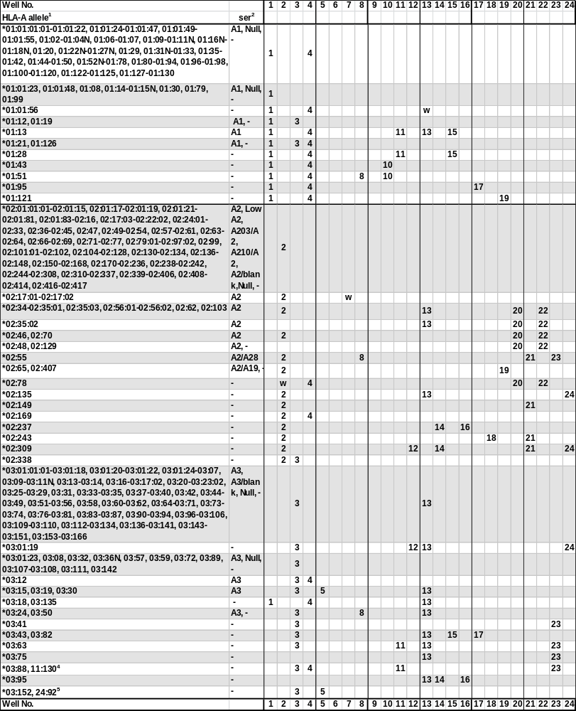
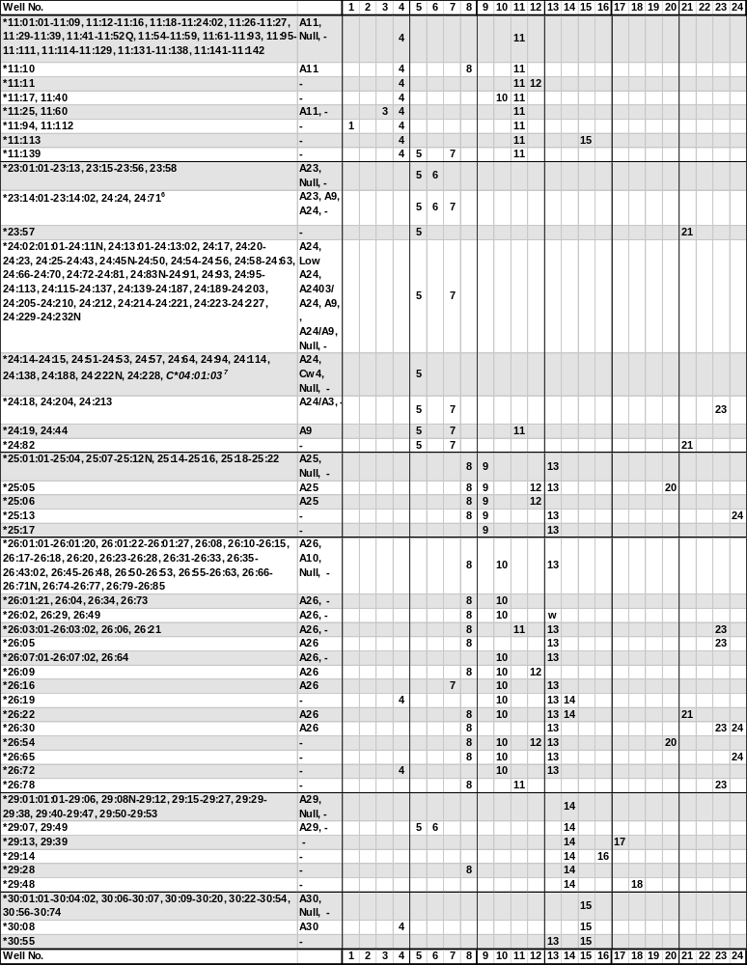
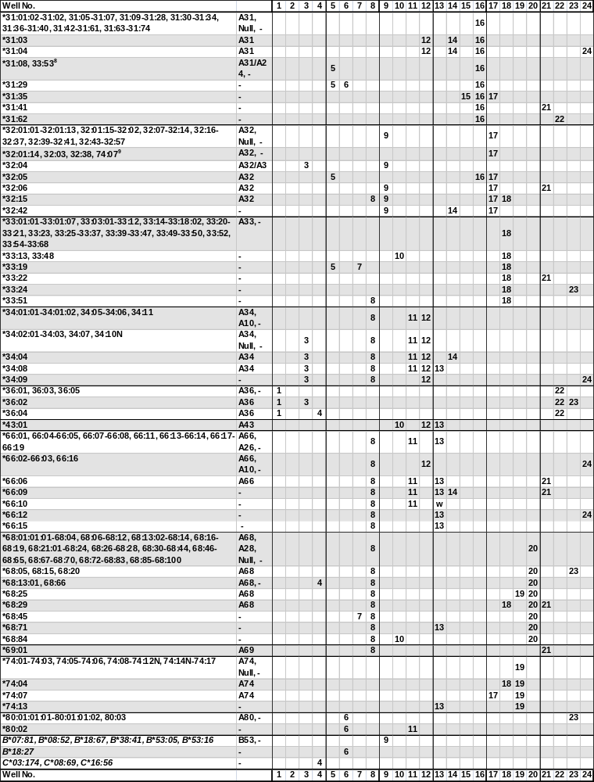
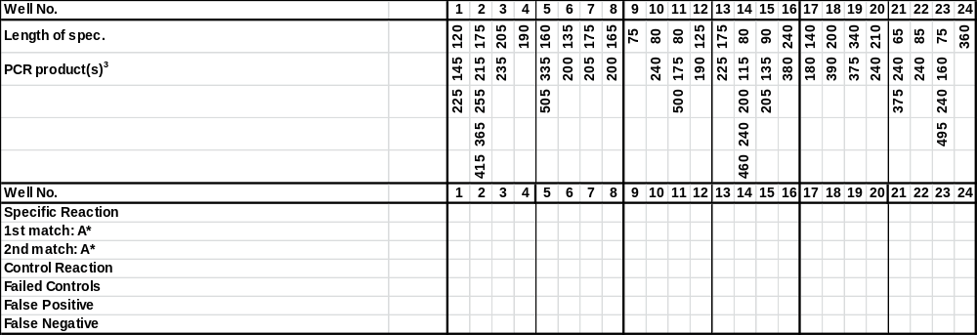
¹The sequence of the A*0105N has been shown to be identical to A*01:04N.
The A*01:34N allele has been renamed A*01:01:38L
The A*020116 allele has been renamed to A*02:134.
The A*020120 has been renamed to A*02:01:18.
The sequence of the A*02:01:82 allele has been shown to be identical to A*02:01:84.
The sequence of the A*0223 allele has been shown to be identical to A*02:22:01.
The sequence of the A*0298 allele has been shown to be identical to A*02:96.
The A*02:100 allele has never been assigned.
The A*1128 allele has been renamed to A*11:15:02.
The A*11:53 allele has been shown to be identical to the corrected A*11:02:01.
The sequence of the A*2401 allele has been shown to be in error.
The sequence of the A*2412 allele has been shown to be identical to A*24:08.
The A*2416 allele has been renamed to A*31:08.
The A*2465 allele has been renamed to A*24:13:02.
The A*24:211 allele has been renamed to A*24:135:02.
The A*26:44 allele has been renamed to A*26:43:02.
The sequence of the A*3005 allele has been shown to be identical to A*30:04.
The A*3021 allele has been renamed to A*30:11:02.
The sequence of the A*31011 allele has been shown to be identical to A*31:01:02.
The sequence of the A*3302 allele has been shown to be identical to A*33:03:01.
The sequence of the A*33:38 allele has been shown to be identical to A*33:44.
²The serological reactivity of all HLA-A alleles is not known. In this table we use the expert-assigned serological grouping in Tissue Antigens (2009) 73:95-170 and the serological grouping of the sequence-defined allele.
³The primer pairs in wells 1, 2, 11, 14 and 15 will in many samples give rise to two or three HLA-specific PCR fragments.
⁴The A*03:88 and the A*11:130 alleles will give rise to identical amplification patterns. These two alleles can be separated by the respective high resolution SSP primer sets.
⁵The A*03:152 and the A*24:92 alleles will give rise to identical amplification patterns. These two alleles can be separated by the respective high resolution SSP primer sets.
⁶The A*23:14:01-23:14:02 and the A*24:24 and 24:71 alleles will give rise to identical amplification patterns. These alleles can be separated by the respective high resolution SSP primer sets.
⁷The 24:14-24:15, 24:51-24:53, 24:57, 24:64, 24:94, 24:114, 24:138, 24:188, 24:222N, 24:228 and the C*04:01:03 alleles may be distinguished by the different sizes of the specific PCR products generated by primer mix 5.
⁸The A*31:08 and A*33:53 alleles will give rise to identical amplification patterns. These two alleles can be separated by the respective high resolution SSP primer sets.
⁹The A*32:01:14, 32:03, 32:38 and the A*74:07 alleles will give rise to identical amplification patterns. These alleles can be separated by the respective high resolution SSP primer sets.
‘w’, may be weakly amplified.
Specificities and sizes of the PCR products of the 48 primer mixes used for HLA-B low resolution SSP typing.

Primer Mix | Size of spec. PCR product¹ | Size of control band² | HLA-B  serol.³ | Amplified HLA-B alleles^{4,5}
25^{6,10} | 110 bp | 800 bp | 7, 703, 40, 41, 42, 48, 61 | *07:02:01-07:18:02, 07:20-07:32, 07:34-07:39, 07:41-07:47, 07:49N-07:50, 07:52, 07:54-07:59, 07:61-07:99, 07:101-07:121, 07:123-07:138, 07:140-07:154, 07:156-07:163, 07:166-07:190, 08:79, 15:138, 15:230, 15:241, 37:07, 40:15-40:16, 40:23, 40:32, 40:98, 40:136, 40:158, 40:183, 40:198, 40:231, 41:08, 42:05:01-42:05:02, 44:150, 48:05, 48:08, 48:15, C*02:23, C*04:77
26 | 215 bp | 1070 bp | 8, 44 | *08:01:01-08:05, 08:07-08:25, 08:27-08:49, 08:51-08:61, 08:63-08:64, 08:66-08:84, 08:86N-08:93, 08:95-08:108, 15:142, 15:180, 35:218, 44:49, 44:156, 49:25, 51:68
27 | 140 bp,  235 bp | 1070 bp | 7, 8, 13, 15, 35, 4005, 44, 49, 61, 62, 77 | *07:20, 07:24, 07:60, 07:100, 07:131, 08:21, 08:25, 13:01:01-13:04, 13:06-13:08, 13:10-13:23, 13:25-13:38, 13:40-13:57, 13:59-13:66, 15:07:01-15:07:02, 15:36^{w}, 15:45, 15:55, 15:68, 15:89^{w}, 15:126, 15:207, 35:05:01-35:05:03, 35:16-35:17, 35:22, 35:30, 35:51, 35:58, 35:72, 35:89, 35:97, 35:113-35:114, 35:125, 35:164, 35:199, 40:05, 40:71, 40:174, 44:08^{w}, 44:54, 44:57^{w}, 44:60, 44:106, 44:110, 44:135, 44:158, 46:12, 51:64, 51:148, 53:14, 55:51, 58:18, C*03:05, C*03:25, C*03:27, C*03:143, C*03:167
28^{7,8,16} | 130 bp,  265 bp | 800 bp | 12, 13, 14, 17, 21, 35, 40, 41, 44, 45, 47, 49, 50, 60, 61, 64, 65 | *13:01:01-13:04, 13:06-13:13, 13:15-13:23, 13:25-13:57, 13:59-13:67, 14:01:01-14:02:08, 14:03-14:04, 14:07N, 14:09, 14:11-14:12, 14:14-14:33, 15:46, 15:53, 15:106, 15:212, 18:44:01-18:44:02, 35:46-35:47, 35:63, 35:154, 35:207, 35:217, 40:01:01-40:01:29, 40:07, 40:10:01-40:10:02, 40:14:01-40:16, 40:22N-40:23, 40:25, 40:30-40:34, 40:36, 40:38, 40:42-40:43, 40:45, 40:47-40:49, 40:51-40:55, 40:58-40:63, 40:65-40:67, 40:69, 40:72:01-40:73, 40:76-40:77, 40:79-40:81, 40:84, 40:87:01-40:88, 40:92, 40:100-40:102, 40:106, 40:108, 40:110, 40:112-40:114, 40:116-40:118N, 40:121, 40:123-40:126, 40:128-40:130, 40:132, 40:134-40:136, 40:139-40:141, 40:146-40:147, 40:150-40:156, 40:158, 40:160:01-40:160:02, 40:163-40:164, 40:166, 40:168, 40:171-40:172, 40:175, 40:178-40:179, 40:182-40:183, 40:186-40:188, 40:191-40:199, 40:204, 40:207-40:208, 40:212-40:213, 40:215-40:219, 40:221-40:223, 40:227-40:228, 40:231, 40:233-40:238, 41:01-41:27, 44:02:01:01-44:03:06, 44:03:08-44:03:15, 44:03:17-44:03:18, 44:04-44:05:04, 44:09-44:39, 44:41:01-44:43:02, 44:45-44:56N, 44:58N-44:80, 44:82, 44:84-44:102, 44:104-44:110, 44:112-44:129, 44:132-44:133, 44:135-44:144, 44:146-44:155, 44:157-44:175, 45:01-45:14, 47:01:01:01-47:08, 49:01:01-49:02, 49:04-49:24, 50:01:01-50:02, 50:04-50:06, 50:08-50:20, 50:31-50:32, 53:30, 57:45, 57:51, C*01:30, C*12:87
29⁸ | 185 bp,  235 bp | 800 bp | 7, 16, 17, 27, 2708, 37, 38, 3901, 3902, 39, 64, 67 | *07:02:32, 14:01:01-14:01:03, 14:07N-14:08, 14:10, 14:12, 14:14, 14:19, 14:26, 14:32, 27:01-27:05:15, 27:05:17-27:05:19, 27:05:21-27:06, 27:08-27:10, 27:12-27:13, 27:16-27:18, 27:20, 27:23, 27:26-27:27, 27:29, 27:31, 27:35-27:37, 27:39-27:42, 27:44-27:46, 27:48-27:61, 27:64N-27:69, 27:72-27:75, 27:77-27:80, 27:82-27:105, 37:02, 38:01:01-38:02:02, 38:02:04-38:03, 38:07-38:24, 38:26-38:32, 38:34N-38:43, 39:01:01:01-39:01:01:03, 39:01:03-39:01:08, 39:01:10-39:02:01, 39:03, 39:05:01-39:09, 39:11, 39:14-39:15, 39:18, 39:19:02, 39:22, 39:24:01-39:39:01, 39:40:01N-39:44, 39:46-39:48, 39:50-39:62, 39:64-39:71, 39:73-39:75, 39:77, 39:79-39:82, 47:04-47:05, 48:21, 48:26, 67:01:01, 67:03
30 | 180 bp | 800 bp | 14, 35, 38, 39, 65 | *07:28, 08:87, 14:02:01-14:02:02, 14:02:04-14:02:05, 14:02:07-14:06:02, 14:09, 14:11, 14:13, 14:15-14:18, 14:20, 14:22-14:23, 14:25, 14:27, 14:29-14:31, 14:33, 15:77, 15:189, 15:233, 35:26, 38:05, 38:33, 39:04, 44:16, 44:37:01-44:37:02, 44:64:01-44:64:02, 44:91, 44:132, 44:150, 52:26, 57:04, A*23:31, A*24:106, C*07:231, C*16:10
31 | 290 bp | 1070 bp | 15, 22, 62, 63, 71, 72, 75, 76, 77, 46 | *15:01:01:01-15:01:03, 15:01:06-15:02:06, 15:03:03, 15:04-15:08, 15:10:02-15:11:03, 15:11:05-15:15, 15:17:01:01-15:17:02, 15:19-15:21, 15:24:01-15:28, 15:30-15:36, 15:38:01-15:40, 15:42-15:46, 15:48, 15:50, 15:55-15:58, 15:60, 15:63, 15:65-15:66, 15:70-15:71, 15:73, 15:75-15:79N, 15:81-15:89, 15:92, 15:94N, 15:96-15:97, 15:101-15:102, 15:104-15:107, 15:109-15:113, 15:116-15:118, 15:120-15:122, 15:125-15:126, 15:128-15:129, 15:135-15:150, 15:152, 15:154-15:155, 15:157, 15:159-15:160, 15:162-15:172, 15:174-15:175,  15:177-15:179, 15:181N-15:185, 15:187-15:196, 15:199, 15:201-15:209N, 15:211, 15:213-15:219, 15:223-15:225, 15:227-15:228, 15:230-15:234,  15:236-15:237, 15:239-15:241, 15:244-15:251, 15:256-15:262N, 15:264-15:265, 15:267-15:273, 46:01:01-46:38, C*01:73, C*07:02:30, C*08:16:02
32 | 165 bp, 220 bp,  285 bp,  330 bp | 1070 bp | 5, 8, 12, 21, 22, 37, 41, 42, 44, 45, 48, 51, 56, 57, 60, 62, 70, 71, 72, 82 | *08:01:01-08:05, 08:08N-08:13, 08:15-08:27, 08:29-08:36, 08:38-08:48, 08:50-08:73, 08:75-08:76, 08:78, 08:80-08:86N, 08:88, 08:90-08:106, 13:46, 15:03:01-15:03:04, 15:09-15:10:02, 15:18:01-15:18:05, 15:23, 15:29, 15:37, 15:46-15:47:02, 15:49, 15:51-15:54, 15:61-15:62, 15:64:01-15:64:02, 15:69, 15:72, 15:74, 15:80, 15:83, 15:90-15:91, 15:93, 15:98-15:99, 15:103, 15:106, 15:108, 15:114-15:115, 15:119, 15:123-15:124, 15:127, 15:131-15:134, 15:143, 15:151, 15:153, 15:156, 15:158, 15:161, 15:173, 15:176, 15:186, 15:197-15:198, 15:200, 15:210, 15:212, 15:220-15:221, 15:226N, 15:229, 15:235, 15:238, 15:242-15:243, 15:252-15:253, 15:255, 15:259, 15:263, 15:266, 15:274-15:275, 35:87, 37:12, 38:30, 40:12, 40:136, 40:231, 41:01-41:03:02, 41:05-41:09, 41:11-41:17, 41:19-41:27, 42:01:01-42:02, 42:04-42:08, 42:10-42:15, 42:17-42:19, 44:14-44:15, 44:18, 44:20, 44:62, 44:100, 44:166, 45:01-45:14, 51:08, 51:20, 51:36, 51:44N, 51:97, 51:141, 52:19, 55:20, 55:56, 56:13, 57:09, 82:01-82:03, C*07:46
33^{8,9,11} | 165 bp, 190 bp, 390 bp | 1070 bp | 5, 17, 21, 35, 51, 5102, 5103, 52, 56, 62, 63, 70, 78 | *13:62, 15:01:02, 15:09, 15:16:01-15:17:02, 15:67, 15:95, 15:162, 15:168, 15:177, 15:196, 15:208, 15:216, 15:222, 15:230, 15:243, 15:254, 15:268, 15:273, 35:01:10, 35:04:02, 40:26, 40:28, 44:62, 49:18, 50:14, 51:01:01-51:01:03, 51:01:05-51:02:03, 51:02:05-51:09:02, 51:11N-51:12, 51:13:02-51:14, 51:16-51:23, 51:24:03-51:24:04, 51:26-51:33, 51:37-51:41N, 51:43-51:44N, 51:46, 51:48-51:61:02, 51:63-51:80, 51:82-51:91, 51:94-51:98N, 51:100-51:130, 51:132-51:142, 51:145-51:147, 51:149N-51:152, 52:01:01:01-52:01:04, 52:01:06-52:01:14, 52:01:16-52:13, 52:15-52:24, 52:26-52:31, 53:28, 56:05:01-56:06, 56:21, 58:08:01-58:08:02, 78:01:01-78:07
34 | 180 bp | 800 bp | 13, 22, 55, 60 | *07:78, 13:01:01-13:02:15, 13:07N-13:09, 13:11, 13:14-13:20, 13:22:01-13:23, 13:25, 13:27-13:34, 13:36-13:45, 13:47, 13:49N-13:50, 13:52, 13:54-13:58, 13:60-13:61, 13:63N-13:67, 40:48, 45:10, 49:07, 50:31, 54:26, 55:09, 55:22, 55:24
35⁶ | 105 bp,  195 bp | 1070 bp | 8, 12, 27, 38, 39, 3902, 40, 44, 45, 48, 60, 70, 71, 72, 82 | *07:27, 07:50, 08:04, 08:17, 08:54, 15:03:01-15:03:04, 15:47:01-15:47:02, 15:49, 15:54, 15:61-15:62, 15:64:01-15:64:02, 15:68-15:69, 15:91, 15:98, 15:103, 15:123, 15:127, 15:131-15:132, 15:151, 15:156, 15:158, 15:173, 15:210, 15:220, 15:235, 15:242, 15:253, 15:259, 15:266, 15:274, 18:37, 27:18, 27:29, 37:28, 38:03, 39:02:01-39:02:02, 39:08, 39:13:01-39:13:02, 39:23, 39:39:01-39:39:02, 39:49, 40:12, 40:46, 40:93, 42:11, 44:10, 44:15, 44:18, 44:40, 44:44, 44:130, 44:140, 44:156, 45:01, 45:05-45:07, 45:11-45:14, 48:01:01-48:05, 48:07-48:30, 49:20, 50:02, 52:16, 55:18, 82:01-82:03
36 | 280 bp | 1070 bp | 5, 7, 8, 13, 15, 16, 17, 18, 22, 35, 40, 42, 44, 46, 48, 49, 51, 53, 55, 56, 57, 58, 60, 61, 62, 63, 70, 71, 72, 75, 76, 77, 78 | *07:09, 07:11, 07:17, 07:162, 08:28, 08:35, 08:37, 08:89, 08:107, 13:04, 13:10, 13:26, 15:01:01:01-15:01:04, 15:01:06-15:08, 15:11:01-15:16:03, 15:18:01-15:21, 15:23-15:29, 15:31-15:36, 15:38:01-15:40, 15:43-15:44, 15:46-15:47:02, 15:49-15:57, 15:60-15:62, 15:64:01-15:72, 15:74-15:76, 15:78:01-15:82, 15:84-15:85, 15:87-15:89, 15:91-15:98, 15:101-15:129, 15:131-15:132, 15:134-15:136, 15:138-15:149N, 15:151-15:161, 15:163-15:167, 15:169-15:176, 15:178-15:187, 15:189-15:195, 15:197-15:207, 15:209N-15:215, 15:217-15:223, 15:225-15:228, 15:231-15:232, 15:234-15:242, 15:244-15:247, 15:249-15:251, 15:254-15:268, 15:270-15:272N, 15:274-15:275, 18:01:01:01-18:15, 18:17N-18:25, 18:27-18:40, 18:42-18:60, 18:62-18:89, 27:41, 35:01:01:01-35:01:37, 35:05:01-35:05:03, 35:07-35:08:06, 35:10-35:11:03, 35:14:01-35:17, 35:19-35:21, 35:23-35:30, 35:32:01-35:32:02, 35:35, 35:37, 35:40N-35:43:01, 35:45-35:54, 35:57-35:58, 35:61:01-35:64:02, 35:66-35:69, 35:71-35:72, 35:76-35:80, 35:82, 35:86, 35:89-35:94, 35:97, 35:99-35:105, 35:107-35:108:02, 35:110-35:126, 35:130N-35:135, 35:137-35:148, 35:158-35:159, 35:161, 35:165N-35:166, 35:168, 35:170-35:171, 35:173N-35:178, 35:180, 35:185-35:192, 35:194, 35:196-35:197, 35:200, 35:202-35:203, 35:206-35:210, 35:212, 35:215-35:219, 35:222, 35:224-35:229, 37:35, 39:07, 39:43, 40:03, 40:20, 40:38, 40:52, 40:59-40:60, 40:105, 40:158-40:159, 40:222, 41:24, 42:09, 44:17, 44:43:01-44:43:02, 44:144, 45:09, 46:01:01-46:10, 46:12-46:17, 46:19-46:38, 48:02:01-48:02:03, 48:14, 48:23, 48:25, 49:04-49:05, 51:37, 51:45, 51:63, 51:97, 53:01:01-53:03, 53:05-53:06, 53:08:01-53:18, 53:20-53:30, 54:06, 54:09, 54:14, 55:14, 55:23, 55:32, 56:03, 56:09, 56:18, 56:31-56:32, 57:01:01-57:01:14, 57:06, 57:08, 57:10-57:11, 57:13-57:16, 57:18-57:27, 57:29-57:31, 57:33-57:38, 57:40-57:41, 57:43-57:45, 57:47-57:56, 57:58-57:62, 57:64, 58:01:01-58:02, 58:04-58:07, 58:09-58:19, 58:21-58:26, 58:29, 58:31N-58:33, 58:35-58:40, 58:42
37 | 195 bp | 1070 bp | 27, 35, 37, 44, 58, 76 | *15:12, 15:14, 15:19, 15:91, 15:131, 15:161, 15:270, 18:54, 18:56, 35:45, 35:71, 37:01:01-37:09, 37:12-37:13, 37:15-37:21, 37:23-37:28, 37:30N-37:33N, 37:35-37:36, 38:17, 44:17, 44:43:01-44:43:02, 44:144, 45:09, 46:17, 53:22, 58:07, A*24:174
38⁶ | 105 bp, 395 bp, 435 bp | 1070 bp | 5, 7, 15, 41, 42, 62, 63, 70, 71, 75, 77 | *07:04, 07:25, 07:146, 15:09-15:10:02, 15:13:01-15:13:02, 15:16:01-15:18:05, 15:21, 15:23-15:24:02, 15:37, 15:44, 15:51-15:52, 15:66-15:67, 15:72, 15:80, 15:87, 15:90, 15:93, 15:95, 15:99, 15:108, 15:114-15:115, 15:119, 15:124, 15:133-15:134, 15:153, 15:157, 15:161-15:162, 15:168, 15:176-15:177, 15:186, 15:189, 15:196-15:198, 15:200, 15:208, 15:216, 15:221-15:222, 15:226N, 15:229-15:230, 15:238, 15:243, 15:252, 15:254, 15:263, 15:268, 15:273, 15:275, 40:136, 40:231, 41:08, 42:05:01-42:05:02
39⁶ | 115 bp,  150 bp | 1070 bp | 18 | *18:01:01:01-18:15, 18:17N-18:28, 18:30-18:71, 18:73-18:89, 48:28
40⁶ | 80 bp | 1070 bp | 7, 27, 2708, 44, 60 | *07:73, 08:88, 08:102, 27:01-27:21, 27:23-27:51, 27:53-27:66N, 27:68-27:74, 27:76-27:105, 38:22, 40:46, 40:93, 44:40, 44:44, 44:130, 49:26
41 | 150 bp | 800 bp | 12, 13, 17, 18, 22, 27, 35, 37, 39, 44, 45, 47, 48, 51, 53, 56, 57, 58, 62, 70, 75, 77, 78 | *08:49, 13:01:01-13:01:06, 13:06-13:07N, 13:12:01-13:13, 13:17, 13:20, 13:22:01-13:23, 13:25-13:26, 13:28-13:29, 13:36, 13:39, 13:43, 13:50-13:52, 13:57, 13:60-13:61, 13:63N, 14:10, 15:02:01-15:02:06, 15:13:01-15:13:02, 15:20-15:21, 15:25:01-15:25:03, 15:36, 15:44, 15:62, 15:77, 15:80, 15:85, 15:88-15:89, 15:106, 15:112, 15:121, 15:139, 15:144, 15:154, 15:165, 15:170, 15:194, 15:204, 15:213-15:214, 15:223, 15:240, 15:250, 15:265, 15:271, 18:22, 18:69, 27:19, 27:30, 35:01:01:01-35:04:03, 35:06-35:08:06, 35:10-35:17, 35:19-35:21, 35:23-35:30, 35:33-35:36, 35:38-35:42:02, 35:45-35:50, 35:52, 35:54-35:57, 35:59, 35:61:01-35:63, 35:65Q, 35:69-35:71, 35:74, 35:76-35:78, 35:80-35:85, 35:90-35:96, 35:98, 35:100-35:101:02, 35:103-35:113, 35:115-35:116, 35:120-35:126, 35:128-35:134N, 35:136-35:150, 35:152-35:173N, 35:175-35:184, 35:186-35:198, 35:200-35:204, 35:206-35:229, 37:01:01-37:01:07, 37:01:09, 37:03N-37:06, 37:08, 37:10-37:11, 37:13-37:37, 38:20, 39:42, 40:28, 44:02:01:01-44:14, 44:16-44:17, 44:19N, 44:21-44:30, 44:32-44:40, 44:42-44:46, 44:48-44:52N, 44:55-44:64:02, 44:66-44:98, 44:101-44:105, 44:107-44:134, 44:136-44:137, 44:139-44:157, 44:159-44:165, 44:167-44:175, 46:33, 48:02:01-48:02:03, 48:25, 50:17, 51:04, 51:42, 51:46, 51:56:01-51:56:02, 51:139, 53:01:01-53:13, 53:15-53:30, 55:14, 56:09, 56:11-56:12, 57:01:01-57:01:04, 57:01:06-57:10, 57:12, 57:14-57:20, 57:22-57:30, 57:32-57:46, 57:48-57:64, 58:01:01-58:01:02, 58:01:04-58:01:12, 58:04-58:05, 58:09-58:15, 58:17N, 58:19, 58:21-58:24, 58:28-58:29, 58:31N-58:37, 58:39N-58:40, 58:42, 83:01, C*03:102
42 | 140 bp | 1070 bp | 8, 18, 22, 35, 39, 78 | *07:65, 07:134, 08:32, 15:202, 15:239, 18:01:01:01-18:08, 18:10-18:15, 18:17N-18:36, 18:38-18:47, 18:50-18:53, 18:55-18:65, 18:68-18:78, 18:80-18:89, 35:01:01:01-35:03:02, 35:03:04-35:18, 35:20:01-35:24:02, 35:28-35:45, 35:48, 35:50-35:55, 35:57-35:62, 35:64:01-35:72, 35:74-35:153, 35:155-35:197, 35:199-35:202, 35:204-35:206, 35:208-35:209, 35:211-35:216N, 35:218-35:229, 37:11, 37:37, 39:19:01-39:19:02, 40:185, 40:209, 56:06, 78:01:01-78:05, 78:07
43^{6,10} | 60 bp,  245 bp, 400 bp | 1070 bp | 5, 15, 44, 48, 60, 62, 63, 70, 71, 72, 75, 76, 77, 82 | *15:01:01:01-15:01:04, 15:01:06-15:21, 15:23-15:40, 15:42-15:58, 15:60-15:67, 15:69-15:99, 15:102-15:129, 15:131-15:179, 15:181N-15:235, 15:237-15:254, 15:256-15:275, 40:12, 82:01-82:03, C*03:179
44¹⁰ | 210 bp | 800 bp | 27, 37 | *07:27, 08:49, 18:54, 37:01:01-37:37, 38:17, C*07:302
45 | 170 bp | 800 bp | 16, 35, 38, 39, 3901, 3902, 67, 72 | *08:55, 15:69, 15:186, 35:35, 38:01:01-38:09, 38:11-38:21, 38:23-38:29, 38:31-38:35, 38:38-38:43, 39:01:01:01-39:01:01:03, 39:01:03-39:20, 39:22-39:24:02, 39:26-39:29, 39:31, 39:35, 39:37-39:42, 39:44-39:46, 39:48-39:49, 39:51-39:73, 39:75-39:81, 40:184, 51:101, 58:20, 67:01:01-67:03, C*15:51
46⁶ | 110 bp | 1070 bp | 38 | *38:01:01-38:02:02, 38:02:04-38:03, 38:05, 38:08-38:24, 38:26-38:34N, 38:36-38:43, 49:26, 52:01:10
47 | 395 bp | 1070 bp | 14, 16, 38, 39, 3901, 64, 65 | *07:69, 07:85, 07:180, 08:65, 14:01:01-14:20, 14:22-14:33, 38:01:01-38:02:05, 38:04-38:05, 38:08-38:25, 38:27-38:43, 39:01:01:01-39:01:01:03, 39:01:03-39:01:16, 39:03-39:07, 39:09, 39:11-39:12, 39:14-39:15, 39:18-39:19:02, 39:22, 39:24:01-39:38Q, 39:40:01N-39:48, 39:50-39:57, 39:59-39:62,  39:64-39:82, 49:26
48 | 160 bp,  425 bp | 1070 bp | 7, 703, 8, 14, 15, 16, 21, 39, 3901, 3902, 40, 41, 42, 45, 48, 50, 60, 61, 64, 65, 67, 70, 73, 81 | *07:02:01-07:26, 07:28-07:35, 07:37, 07:39-07:64, 07:66-07:80, 07:82-07:148, 07:150-07:178, 07:181N-07:190, 08:01:01-08:01:20, 08:04-08:05, 08:07-08:35, 08:37-08:51, 08:53:01-08:77, 08:79-08:108, 14:01:01-14:02:04, 14:02:06-14:02:07, 14:02:09-14:29, 14:31-14:33, 27:14, 27:81, 39:01:01:01-39:01:01:03, 39:01:03-39:20, 39:22-39:24:01, 39:25N-39:82, 40:01:01-40:01:29, 40:06:01:01-40:06:04, 40:06:06-40:07, 40:09?, 40:11:01?-40:11:02?, 40:14:01?-40:15?, 40:16, 40:18?, 40:21?-40:22N?, 40:23, 40:24?-40:38?, 40:42?-40:43?, 40:44, 40:45?-40:46?, 40:48?-40:50?, 40:51, 40:52?, 40:53, 40:54?-40:58?, 40:59-40:60, 40:61?-40:65?, 40:66, 40:67?-40:69?, 40:70, 40:71?, 40:72:01-40:73, 40:74?, 40:75, 40:77, 40:78?, 40:79, 40:80?-40:82?, 40:83, 40:84?-40:85?, 40:86, 40:87:01?-40:88?, 40:90?-40:92?, 40:93, 40:95?, 40:96, 40:98?-40:102?, 40:103, 40:104?-40:108?, 40:109-40:110, 40:111?-40:116?, 40:118N?-40:121?, 40:123?, 40:124:01, 40:124:02?-40:126?, 40:127, 40:128?-40:130?, 40:131, 40:132?-40:134?, 40:136?-40:137?, 40:138-40:140, 40:141?, 40:145?, 40:146-40:148, 40:149?, 40:150, 40:151?, 40:152-40:153, 40:154?, 40:155N, 40:156?, 40:158?, 40:159, 40:160:01?-40:160:02?, 40:161-40:162, 40:163?-40:164?, 40:165, 40:166?, 40:167, 40:168?-40:171?, 40:172, 40:173?-40:176?, 40:177, 40:178?-40:185?, 40:186, 40:187?, 40:189?, 40:190, 40:191?-40:200?, 40:202?-40:213?, 40:215?-40:228?, 40:230, 40:231?-40:238?, 41:01-41:27, 42:01:01-42:02, 42:04-42:20, 45:01-45:14, 48:01:01-48:17, 48:19-48:30, 50:01:01-50:02, 50:04-50:20, 50:31-50:32, 51:01:09, 51:01:21, 51:01:25, 51:10, 51:24:02-51:24:04, 54:11, 56:20:02, 67:01:01-67:03, 73:01-73:02, 81:02
49¹² | 180 bp | 1070 bp | 15, 40, 44, 48, 60, 62, 71 | *15:116, 15:124, 40:01:01-40:01:06, 40:01:08-40:01:17, 40:01:19-40:01:29, 40:07, 40:10:01-40:10:02, 40:12, 40:21-40:23, 40:25, 40:30, 40:33-40:34, 40:36, 40:38, 40:42-40:43, 40:46-40:49, 40:51-40:52, 40:54-40:55, 40:59-40:63, 40:65-40:67, 40:69, 40:73-40:74, 40:76, 40:79, 40:81, 40:84, 40:87:01-40:88, 40:92, 40:100-40:102, 40:106, 40:108, 40:112-40:114, 40:116-40:118N, 40:123-40:126, 40:128, 40:130, 40:132, 40:134-40:135, 40:137-40:141, 40:146-40:147, 40:149-40:156, 40:160:01-40:160:02, 40:163, 40:166, 40:168, 40:170-40:172, 40:175, 40:178-40:179, 40:182-40:183, 40:185-40:188, 40:191, 40:193-40:196, 40:198-40:199, 40:204, 40:207-40:208, 40:210, 40:212-40:213, 40:215-40:218, 40:221-40:223, 40:227-40:228, 40:231, 40:234-40:236, 40:238, 44:31, 44:169, 46:06, 48:03:01-48:03:02, 48:17, 48:23, 57:59, C*03:129, C*17:16
50^{10,17} | 290 bp, 465 bp | 1070 bp | 21, 4005, 41, 50, 60, 61 | *13:02:06, 13:26, 15:16:03, 15:20, 15:85, 15:194, 18:48, 35:46, 35:207, 40:02:01-40:06:07, 40:08, 40:09?, 40:10:02?-40:11:02?, 40:13, 40:14:01?-40:15?, 40:18?-40:19?, 40:20, 40:22N?, 40:24?-40:38?, 40:39, 40:42?-40:45?, 40:47?-40:50?, 40:52?-40:58?, 40:61?-40:65?, 40:67?-40:69?, 40:70, 40:71?, 40:72:02?, 40:74?-40:76?, 40:78?, 40:80?-40:82?, 40:84?-40:88?, 40:89, 40:90?-40:92?, 40:94, 40:95?-40:96?, 40:97, 40:98?-40:121?, 40:122, 40:123?, 40:124:02?-40:136?, 40:141?, 40:142N-40:144N, 40:145?, 40:148?-40:149?, 40:151?, 40:154?, 40:156?-40:169?, 40:171?, 40:173?-40:176?, 40:178?-40:184?, 40:187?-40:208?, 40:210?-40:213?, 40:214, 40:216N?-40:228?, 40:229, 40:230?-40:238?, 46:01:07, 46:33, 47:01:01:01-47:08, 57:05, 58:36, C*01:73
51⁶ | 105 bp | 1070 bp | 7, 8, 22, 41, 42 | *07:04, 07:25, 07:146, 08:01:01-08:05, 08:07-08:12:03, 08:14-08:19N, 08:21-08:24, 08:26-08:39, 08:41-08:54, 08:56:01-08:69, 08:71-08:78, 08:80-08:102, 08:104-08:108, 35:87, 40:136, 40:231, 41:01-41:08, 41:10-41:27, 42:01:01-42:02, 42:04-42:07, 42:09-42:18, 42:20, 44:166, 55:20
52 | 325 bp | 800 bp | 7, 22, 27, 2708, 35, 42, 45, 46, 54, 55, 56, 67, 73, 78, 81, 82 | *07:02:01-07:02:38, 07:04-07:07, 07:09-07:15, 07:17-07:26, 07:28-07:31, 07:33-07:36, 07:39-07:46, 07:47^{w}, 07:48-07:49N, 07:51-07:68:03, 07:70-07:84, 07:86-07:179, 07:181N-07:190, 14:21, 15:76, 15:101, 15:255, 27:01-27:11, 27:13-27:15, 27:17, 27:19-27:21, 27:24-27:28, 27:30-27:38, 27:40-27:58, 27:60-27:76, 27:78-27:91, 27:93-27:105, 35:76, 35:186, 35:229, 38:26, 40:166, 42:01:01-42:02, 42:04-42:06, 42:08-42:10, 42:12-42:20, 44:90, 44:97, 45:06, 46:01:01-46:01:09, 46:02^{w}, 46:03-46:38, 54:01:01-54:28, 55:01:01-55:05, 55:07-55:17, 55:19-55:58, 56:01:01-56:16, 56:18-56:22, 56:24-56:32, 56:34-56:39, 67:01:01-67:03, 73:01-73:02, 81:01-81:06, 82:01-82:03, 83:01
53^{6,8,10} | 80 bp, 115 bp, 160 bp, 195 bp, 225 bp, 260 bp | 1070 bp | 35, 37, 44, 47, 57 | *08:49, 08:60, 08:76, 08:87, 35:38, 35:45, 35:71, 35:115, 35:169, 37:01:01-37:01:07, 37:01:09, 37:03N-37:06, 37:08, 37:10-37:37, 40:132, 40:178, 40:231, 42:13, 44:02:01:01-44:14, 44:16-44:17, 44:19N-44:36, 44:38-44:63, 44:65-44:134, 44:136-44:149N, 44:151-44:157, 44:159-44:165, 44:167-44:175, 51:42, 53:22, 57:07, 57:09, 57:24, 83:01, C*15:25
54 | 215 bp | 800 bp | 5, 8, 12, 17, 21, 22, 41, 42, 44, 45, 51, 5102, 5103, 52, 53, 56, 62 | *08:09, 08:84, 13:46, 15:83, 41:01, 41:05-41:07, 41:09, 41:12, 41:14, 41:16-41:17, 41:20-41:22, 41:25-41:26, 42:04, 44:06, 44:15, 44:18, 44:20, 44:100, 45:01-45:14, 51:01:01, 51:01:03-51:01:08, 51:01:10-51:01:39, 51:01:41-51:02:01, 51:02:03-51:04, 51:06:01-51:07:01, 51:08-51:09:01, 51:10-51:14, 51:16-51:24:04, 51:26-51:46, 51:48-51:53, 51:55-51:77, 51:79-51:88, 51:90-51:92, 51:94-51:102, 51:104-51:115, 51:117-51:118N, 51:120-51:131, 51:133-51:143, 51:145-51:147, 51:149N-51:152, 52:01:02, 52:01:04, 52:01:09, 52:02:01-52:03, 52:06:01-52:06:02, 52:09, 52:19, 52:21, 53:06, 55:20, 55:56, 56:13, 58:08:01
55 | 130 bp,  270 bp | 800 bp | 17, 18, 22, 35, 37, 46, 51, 53, 62, 78 | *14:10, 15:57^{w}, 18:22, 18:69, 35:21, 35:24:01-35:24:02, 35:81, 35:96, 35:109, 35:157, 35:188, 35:190, 37:04:01-37:04:02, 40:28, 46:01:01-46:38, 51:04, 51:46, 51:56:01-51:56:02, 51:139, 53:02, 53:06, 53:28, 57:14, 58:09, C*01:73, C*15:39
56^{6,13} | 90 bp,  410 bp | 1070 bp | 15, 22, 27, 35, 47, 54, 55, 56, 78, 81, 82 | *07:65, 27:01^{w}, 27:02:01-27:11, 27:13-27:15, 27:17, 27:19-27:21, 27:24-27:28, 27:30-27:38, 27:40-27:58, 27:60-27:76, 27:78-27:91, 27:93-27:105, 35:76, 35:186, 35:229, 44:90, 44:97, 47:01:01:01-47:03, 47:06-47:08, 54:01:01-54:28, 55:01:01-55:05, 55:07-55:17, 55:19-55:58, 56:01:01-56:16, 56:18-56:22, 56:24-56:32, 56:34-56:39, 81:01, 82:01-82:03, 83:01
57⁶ | 90 bp,  175 bp | 1070 bp | 15, 27, 35, 48, 60, 62, 75, 77, 81 | *07:174, 13:36, 15:02:01-15:02:06, 15:08, 15:11:01-15:11:05, 15:13:01-15:13:02, 15:15, 15:21, 15:31, 15:44, 15:55, 15:76^{w}, 15:88-15:89, 15:112, 15:121, 15:139, 15:144, 15:148, 15:170, 15:189, 15:191, 15:194, 15:209N, 15:213-15:215, 15:223, 15:265, 27:24, 35:46, 40:31, 40:45, 40:80, 48:01:01-48:01:04, 48:04, 48:06-48:07, 48:09, 48:11, 48:15-48:16, 48:18-48:20, 48:22, 48:24, 48:27-48:30, 56:39^{w}, 81:01-81:06
58 | 145 bp,  430 bp | 1070 bp | 44, 49, 59, 61 | *40:13, 40:19, 40:109, 40:117, 44:18, 44:25, 44:50, 44:95, 49:01:01-49:01:04, 49:04-49:25, 51:112, 53:30, 54:12, 56:21, 57:45, 57:51, 59:01:01:01-59:05
59⁶ | 120 bp,  210 bp | 800 bp | 5, 13, 15, 17, 22, 35, 45, 49, 50, 51, 5102, 5103, 52, 55, 56, 62, 63, 78 | *07:78, 07:84, 13:16, 13:31^{w}, 13:48, 13:62, 15:04^{w}, 15:16:01-15:16:03, 15:42, 15:67, 15:95, 15:137^{w}, 15:254, 40:95, 40:148, 40:161, 46:32^{w}, 49:01:01, 49:01:03-49:10, 49:12-49:26, 50:01:01-50:02,  50:04-50:11, 50:13-50:16, 50:18-50:20, 50:31-50:32, 51:01:01-51:03, 51:05, 51:07:01-51:09:02, 51:11N-51:14, 51:16-51:24:04, 51:26-51:41N, 51:43-51:44N, 51:48-51:55, 51:57-51:58, 51:60-51:61:02, 51:63, 51:65-51:80, 51:82-51:134, 51:136-51:138, 51:140-51:147, 51:149N-51:152, 52:01:01:01-52:31, 54:20, 55:01:01-55:01:06, 55:01:08-55:01:10, 55:03, 55:05, 55:09, 55:11, 55:15, 55:17, 55:21^{w}, 55:24-55:25, 55:28-55:29, 55:31, 55:33, 55:36, 55:38, 55:40, 55:44-55:45, 55:52-55:55N, 55:58, 56:05:01-56:06, 56:21, 56:25, 56:37, 58:08:01-58:08:02, 78:01:01-78:07
60 | 430 bp | 1070 bp | 5, 17, 27, 44, 51, 5102, 5103, 52, 53, 57, 58, 61 | *18:67, 27:02:01-27:02:02, 27:30, 27:53, 27:57, 27:62, 27:65N, 27:75, 27:77, 27:83, 27:95, 27:102, 37:34, 40:13, 40:19, 40:109, 40:117, 44:06, 44:25, 44:50, 44:95, 51:01:01-51:01:39, 51:01:41-51:24:04, 51:26-51:46, 51:48-51:53, 51:55-51:77, 51:79-51:152, 52:01:01:01-52:19, 52:21-52:31, 53:01:01-53:02, 53:04-53:08:02, 53:10, 53:14-53:30, 57:01:01-57:11, 57:13-57:64, 58:01:01-58:02, 58:04-58:16, 58:18-58:29, 58:31N-58:40, 58:42
61 | 145 bp | 1070 bp | 12, 21, 35, 40, 4005, 41, 45, 47, 50, 60, 61 | *07:133, 15:46, 15:53, 15:106, 15:143, 15:212, 18:48, 35:19, 35:47, 35:63, 35:154, 35:217, 39:69, 40:01:01-40:11:02, 40:14:01-40:16, 40:18, 40:20, 40:22N-40:40, 40:42-40:45, 40:48-40:75, 40:77-40:92, 40:94-40:95, 40:97-40:108, 40:111-40:116, 40:118N-40:136, 40:138-40:156, 40:158-40:184, 40:186-40:187, 40:189-40:200, 40:202-40:207, 40:210-40:238, 41:01-41:04, 41:05?, 41:06-41:25, 41:27, 44:09, 44:46, 44:75, 44:90, 44:129, 44:131, 45:01-45:14, 47:02, 47:03^{w}, 50:01:01-50:02, 50:04-50:05, 50:07-50:20, 50:31-50:32
62 | 300 bp | 1070 bp | 7, 12, 13, 15, 17, 18, 21, 27, 2708, 35, 37, 38, 39, 3902, 40, 4005, 41, 44, 45, 47, 48, 49, 50, 52, 60, 61, 62, 70, 72, 76 | *07:54, 07:123, 08:17, 08:38, 08:54, 08:101, 13:01:01-13:04, 13:06, 13:08-13:23, 13:25-13:35, 13:37-13:67, 15:01:01:01-15:01:04, 15:01:06-15:01:18, 15:01:20-15:01:32, 15:03:01-15:07:02, 15:12, 15:14, 15:19-15:20, 15:24:01-15:27:03, 15:30, 15:32-15:36, 15:38:01-15:40, 15:42-15:43, 15:45-15:50, 15:53-15:54, 15:56-15:58, 15:60-15:63, 15:65-15:66, 15:68-15:71, 15:73-15:75, 15:77-15:79N, 15:81-15:87, 15:91-15:92, 15:94N, 15:96-15:98, 15:101-15:107, 15:109-15:111N, 15:113, 15:116-15:118, 15:122-15:123, 15:125-15:129, 15:131-15:132, 15:135-15:138, 15:140-15:142, 15:145-15:147, 15:150-15:152, 15:154-15:160, 15:163-15:167, 15:169, 15:171-15:175, 15:178-15:179, 15:181N-15:185, 15:187-15:188, 15:190N, 15:192-15:193, 15:195, 15:199, 15:201-15:207,  15:210-15:212, 15:217-15:220, 15:224-15:225, 15:227-15:228, 15:231-15:237, 15:239-15:245Q, 15:247-15:251, 15:253, 15:255-15:262N, 15:264, 15:266-15:267, 15:269-15:272N, 15:274, 18:12, 27:01-27:21, 27:24-27:91, 27:93-27:105, 35:10, 35:13, 35:16, 35:28, 35:63, 35:69, 35:80, 35:207, 35:226, 37:01:01-37:07, 37:09-37:37, 38:03-38:04, 38:25, 39:02:01-39:02:02, 39:08, 39:13:01-39:13:02, 39:22-39:23, 39:49, 40:01:01-40:07, 40:09-40:16, 40:18-40:24, 40:26-40:40, 40:42-40:67, 40:70-40:105, 40:107-40:165, 40:167-40:231, 40:233-40:238, 41:01-41:27, 42:11, 44:02:01:01-44:02:21, 44:02:23-44:05:04, 44:07-44:11, 44:13-44:170, 44:172-44:175, 45:01-45:14, 47:01:01:01-47:08, 48:01:01-48:05, 48:07-48:15, 48:17-48:30, 49:01:01-49:25, 50:01:01-50:02, 50:04-50:14, 50:16-50:20, 50:31-50:32, 52:01:01:01-52:31, 53:17:01-53:17:02, 53:28, 55:18, 55:34, 55:40, 78:05-78:06
63⁸ | 160 bp,  330 bp | 1070 bp | 22, 44, 45, 47, 54 | *08:87, 44:02:01:01-44:02:29, 44:06, 44:08-44:09, 44:11-44:12, 44:16, 44:19N-44:24, 44:27:01-44:27:02, 44:33-44:34:02, 44:41:01-44:41:02, 44:44, 44:48-44:49, 44:52N-44:53, 44:55, 44:59:01-44:59:02, 44:63, 44:66-44:68, 44:71-44:74, 44:80, 44:83-44:84, 44:86-44:87, 44:89-44:91, 44:93, 44:95, 44:97, 44:99-44:102, 44:104, 44:106, 44:112-44:113, 44:116, 44:118-44:119, 44:121, 44:126:01-44:127, 44:131-44:132, 44:137-44:138Q, 44:142, 44:145, 44:148-44:149N, 44:151-44:152, 44:162, 44:168-44:173, 54:01:01, 54:01:03-54:28, 83:01
64 | 180 bp,  210 bp | 1070 bp | 13, 15, 18, 35, 39, 40, 54, 55, 56, 59, 78 | *07:65, 13:06, 13:53, 15:42, 15:86, 15:224, 18:04, 35:08:05, 35:42:02, 35:60, 35:185, 39:17, 39:63, 40:01:11, 40:58, 45:08, 46:18, 54:01:01-54:02, 54:05N, 54:07-54:08N, 54:10, 54:12-54:13, 54:16-54:25, 54:27-54:28, 55:01:01-55:03, 55:05, 55:07, 55:10-55:12, 55:15-55:16, 55:18-55:19, 55:21, 55:25-55:26, 55:29-55:31, 55:33-55:45, 55:47-55:48, 55:50, 55:52-55:57, 56:05:01, 56:06, 56:10, 56:23, 59:01:01:01-59:01:01:02, 59:05, 78:01:01-78:01:02, 78:02:02-78:03, 78:07, C*15:02:04
65 | 180 bp | 1070 bp | 12, 15, 21, 22, 44, 45, 49, 50, 51, 56, 61, 62, 82 | *13:03, 13:48, 15:73, 40:71, 44:10, 44:15, 44:18, 44:140, 45:01, 45:04-45:07, 45:11-45:14, 46:11, 49:01:01-49:03, 49:06, 49:08-49:17, 49:19N-49:26, 50:01:01-50:02, 50:04-50:08, 50:10-50:13,  50:15-50:19, 50:32, 51:15, 51:62, 51:106, 52:25, 54:03, 56:01:01-56:01:04, 56:02, 56:04, 56:07-56:08, 56:13-56:14, 56:16-56:17, 56:20:01-56:20:02, 56:24-56:30, 56:33-56:39, 59:04, 82:01-82:03, C*03:19, C*03:102
66⁶ | 90 bp,  240 bp | 800 bp | 57 | *55:14, 57:01:01-57:44, 57:46-57:50, 57:52-57:64, 58:36, C*06:72
67^{6,13} | 90 bp | 1070 bp | 5, 13, 15, 17, 39, 55, 56, 58, 60, 61, 62, 71 | *07:182N, 13:11, 15:18:03, 15:73, 15:224, 39:17, 40:48, 40:71, 51:62, 56:02, 56:04, 56:10, 58:01:01-58:02, 58:04-58:29, 58:31N-58:35, 58:37-58:40, 58:42, C*02:06^{w}, C*02:47^{w}
68⁶ | 95 bp | 1070 bp | 8, 18, 22, 35, 37, 38, 39, 44, 51, 5102, 5103, 53, 78 | *07:65^{w}, 07:134^{w}, 08:32, 18:01:01:01-18:11, 18:13-18:15, 18:17N-18:36, 18:38-18:47, 18:49-18:65, 18:67-18:89, 35:01:01:01-35:08:04, 35:08:06-35:09:03, 35:11:01-35:12:03, 35:14:01-35:15, 35:17-35:18, 35:20:01-35:24:02, 35:27, 35:29:01-35:45, 35:48, 35:50-35:62, 35:64:01-35:68:02, 35:70-35:72, 35:74-35:75, 35:76^{w}, 35:77-35:79, 35:81-35:153, 35:155-35:185, 35:187-35:190, 35:192-35:197, 35:199-35:206, 35:208-35:209, 35:211-35:216N, 35:218-35:225, 35:227-35:229, 37:08, 38:06-38:07, 39:19:01-39:19:02, 44:06, 51:01:01-51:24:04, 51:26-51:46, 51:48-51:103, 51:105-51:111, 51:113-51:117, 51:119-51:146, 51:148-51:152, 53:01:01-53:16, 53:18-53:27, 53:29, 56:06^{w}, 78:01:01-78:04, 78:07
69^{6,10} | 115 bp,  150 bp | 1070 bp | 15, 18,22, 27, 35, 39, 46, 55, 62, 72, 73, 75, 76 | *07:100, 13:31, 13:41, 15:01:01:01-15:01:04, 15:01:06-15:01:16, 15:01:18-15:01:30, 15:01:32, 15:04, 15:07:01-15:08, 15:11:01-15:12, 15:14-15:15, 15:19, 15:24:01-15:24:02, 15:26N-15:28, 15:30, 15:32, 15:34-15:35, 15:38:01-15:38:02, 15:43, 15:45-15:46, 15:50, 15:53-15:54, 15:56-15:58, 15:60, 15:63, 15:66, 15:68, 15:70-15:71, 15:73, 15:75-15:77, 15:79N, 15:81-15:82, 15:85, 15:87, 15:92, 15:94N, 15:96-15:97, 15:101-15:102, 15:104-15:105, 15:109-15:111N, 15:113, 15:117-15:118, 15:120, 15:122, 15:125-15:126, 15:128-15:129, 15:135, 15:137, 15:140, 15:142-15:149N, 15:152, 15:154, 15:157, 15:159-15:160, 15:163-15:167, 15:169, 15:171-15:172, 15:174-15:175, 15:178, 15:180-15:184, 15:187, 15:189-15:193, 15:201-15:203, 15:205-15:207, 15:209N, 15:211-15:212, 15:215, 15:217, 15:225, 15:227-15:228, 15:231-15:234, 15:236, 15:239, 15:241, 15:244-15:247, 15:251, 15:256-15:262N, 15:264, 15:267, 15:269-15:270, 15:272N, 18:19, 27:25, 27:75, 35:14:01-35:14:02, 35:43:01-35:44, 35:62, 35:67, 35:79, 35:86, 35:102, 35:117, 35:135, 35:163, 35:185, 35:213, 39:18, 39:36, 44:146, 46:01:01-46:02, 46:04-46:05, 46:07N, 46:09-46:10, 46:12, 46:14-46:17, 46:20, 46:22-46:24, 46:26-46:32, 46:34-46:38, 51:61:01-51:61:02, 52:21, 54:06, 55:21, 56:03, 73:01-73:02, A*26:68, A*68:56, C*02:56, C*06:20, C*12:50
70¹⁵ | 360 bp | 1070 bp | B^{w}4 | *07:27, 07:36, 07:38, 07:81, 07:149, 07:180, 08:02-08:03, 08:52, 08:78, 13:01:01-13:04, 13:06-13:08, 13:10-13:23, 13:25-13:38, 13:40-13:66, 15:13:01-15:13:02, 15:16:01-15:17:02, 15:23-15:24:02, 15:36, 15:43, 15:67, 15:87, 15:89, 15:95, 15:115, 15:157, 15:162, 15:168, 15:177, 15:196, 15:208, 15:216, 15:222, 15:230, 15:254, 15:256, 15:268, 15:273, 18:09, 18:54, 18:67, 27:01-27:07:03, 27:09-27:11, 27:13-27:17, 27:19-27:21, 27:23-27:25, 27:27-27:32, 27:34-27:39, 27:41, 27:43, 27:45-27:88, 27:90:01-27:105, 37:01:01-37:04:02, 37:06-37:10, 37:12-37:36, 38:01:01-38:43, 40:13, 40:19, 40:47, 40:96, 40:109-40:110, 40:117, 40:157, 40:188, 40:201, 44:02:01:01-44:08, 44:10-44:45, 44:47-44:74, 44:76-44:89, 44:91-44:126:02, 44:128, 44:130, 44:132-44:175, 47:01:01:01-47:01:02, 47:03-47:08, 48:18, 49:01:01-49:20, 49:22-49:26, 51:01:01-51:24:04, 51:26-51:46, 51:48-51:152, 52:01:01:01-52:31, 53:01:01-53:30, 54:12, 56:07, 56:21, 57:01:01-57:11, 57:13-57:64, 58:01:01-58:02, 58:04-58:29, 58:31N-58:40, 58:42, 59:01:01:01-59:05
71 | 350 bp | 1070 bp | B^{w}6 | *07:02:01-07:26, 07:28-07:35, 07:37, 07:39-07:80, 07:82-07:148, 07:150-07:179, 07:181N-07:190, 08:01:01-08:01:20, 08:04-08:05, 08:07-08:51, 08:53:01-08:77, 08:79-08:108, 13:09, 13:39, 13:67, 14:01:01-14:33, 15:01:01:01-15:01:04, 15:01:06-15:12, 15:14-15:15, 15:18:01-15:21, 15:25:01-15:35, 15:37-15:40, 15:42, 15:44-15:58, 15:60-15:66, 15:68-15:86, 15:88, 15:90-15:94N, 15:96-15:99, 15:101-15:114, 15:116-15:129, 15:131-15:156, 15:158-15:161, 15:163-15:167, 15:169-15:176, 15:178-15:195, 15:197-15:207, 15:209N-15:215, 15:217-15:221, 15:223-15:229, 15:231-15:253, 15:255, 15:257-15:267, 15:269-15:272N, 15:274-15:275, 18:01:01:01-18:08, 18:10-18:15, 18:17N-18:53, 18:55-18:66, 18:68-18:89, 27:08, 27:12, 27:18, 27:26, 27:33, 27:40, 27:42, 27:44, 27:89, 35:01:01:01-35:72, 35:74-35:221, 35:223-35:229, 37:05, 37:11, 37:14^{w}, 37:37, 39:01:01:01-39:01:01:03, 39:01:03-39:01:14, 39:01:16-39:20, 39:22-39:82, 40:01:01-40:12, 40:14:01-40:16, 40:18, 40:20-40:40, 40:42-40:46, 40:48-40:75, 40:77-40:95, 40:97-40:108, 40:111-40:116, 40:118N-40:156, 40:158-40:187, 40:189-40:200, 40:202-40:238, 41:01-41:25, 41:27, 42:01:01-42:02, 42:04-42:20, 44:09, 44:46, 44:75, 44:90, 44:129, 44:131, 45:01-45:14, 46:01:01-46:38, 47:02, 47:03^{w}, 48:01:01-48:17, 48:19-48:30, 50:01:01-50:02, 50:04-50:20, 50:31-50:32, 54:01:01-54:11, 54:13-54:28, 55:01:01-55:05, 55:07-55:58, 56:01:01-56:06, 56:08-56:20:02, 56:22-56:39, 57:12, 67:01:01-67:03, 73:01-73:02, 78:01:01-78:07, 81:01-81:06, 82:01-82:03, 83:01
72 | 285 bp | 800 bp | 7, 703, 8, 35, 40, 41, 42, 48, 53, 60, 61, 81 | *07:02:01-07:06, 07:08-07:18:02, 07:20-07:32, 07:34-07:39, 07:41-07:52, 07:54-07:59, 07:61-07:76, 07:79-07:83, 07:85-07:99, 07:101-07:121, 07:123-07:138, 07:140-07:164, 07:166-07:190, 08:01:01-08:05, 08:07-08:08N, 08:10-08:11, 08:13-08:15, 08:17-08:83, 08:85-08:88, 08:90-08:102, 08:104-08:106, 08:108, 35:66, 35:87, 37:07, 40:15-40:16, 40:30-40:32, 40:34, 40:45, 40:59, 40:80, 40:98, 40:137, 40:160:01-40:160:02, 41:02:01-41:02:05, 41:04, 41:10-41:11, 41:13, 41:18-41:19, 41:23-41:24, 41:27, 42:01:01-42:02, 42:05:01-42:07, 42:09-42:13, 42:15-42:20, 44:150, 44:166, 48:01:01-48:01:04, 48:05-48:12, 48:14-48:20, 48:22, 48:27-48:30, 53:15, 81:01-81:06

¹Alleles are assigned by the presence of specific PCR product(s). However, the sizes of the specific PCR products may be helpful in the interpretation of HLA-B low resolution SSP typings.
When the primers in a primer mix can give rise to HLA-specific PCR products of more than one length this is indicated if the size difference is more than 20 base pairs. Size differences of 20 base pairs or less are not given. For high resolution SSP kits the respective lengths of the HLA-specific PCR product(s) are given for the alleles amplified by these primer mixes.
Nonspecific amplifications, i.e. a ladder or a smear of bands, may sometimes be seen. GC-rich primers have a higher tendency of giving rise to nonspecific amplifications than other primers.
PCR fragments longer than the control bands may sometimes be observed. Such bands should be disregarded and do not influence the interpretation of the SSP typings.
PCR fragments migrating faster than the control bands, but slower than a 400 bp fragment may be seen in some gel read-outs. Such bands can be disregarded and do not influence the interpretation of the SSP typings.
Some primers may give rise to primer oligomer artifacts. Sometimes this phenomenon is an inherit feature of the primer pair(s) of a primer mix. More often it is due to other factors such as too low amount of DNA in the PCR reactions, taking too long time in setting up the PCR reactions, working at elevated room temperature or using thermal cyclers that are not pre-heated.
²The internal positive control primer pairs amplify segments of the human growth hormone gene. The two different control primer pairs give rise to either an internal positive control band of 1070 base pairs, for most wells, or a band of 800 base pairs, for some wells.
Well number 25 contains the primer pair giving rise to the shorter, 800 bp, internal positive control band. In addition, wells number 28 to 30, 34, 41, 44, 45, 52, 54, 55, 59, 66 and 72 contain the primer pair giving rise to the shorter, 800 bp, internal positive control band.
In the presence of a specific amplification the intensity of the control band often decreases.
³The serological reactivity of all HLA-B alleles is not known. In this table we use the expert-assigned serological grouping in Tissue Antigens (2009) 73:95-170 and the serological grouping of the sequence-defined allele.
⁴For several HLA Class I alleles 1st and/or 4th exon(s) and beyond, as well as intron nucleotide sequences, are not available. In these instances it is not known whether some of the primers of the SSP sets are completely matched with the target sequences or not. We assume that unknown sequences in these regions are conserved within allelic groups.
⁵Due to the sharing of sequence motifs between HLA-Class I alleles, the C*02:23 and C*04:77 alleles will be amplified by primer mix 25, the C*03:05, C*03:25, C*03:27, C*03:143 and C*03:167 alleles will be amplified by primer mix 27, the C*01:30 and C*12:87 alleles will be amplified by primer mix 28, the A*23:31, A*24:106, C*07:231 and C*16:10 alleles will be amplified by primer mix 30, the C*01:73 allele will be amplified by primer mixes 31, 50 and 55, the C*07:02:30 and C*08:16:02 alleles will be amplified by primer mix 31, the C*07:46 allele will be amplified by primer mix 32, the A*24:174 allele will be amplified by primer mix 37, the C*03:102 allele will be amplified by primer mixes 41 and 65, the C*03:179 allele will be amplified by primer mix 43, the C*07:302 allele will be amplified by primer mix 44, the C*15:51 allele will amplified by primer mix 45, the C*03:129 and C*17:16 alleles will be amplified by primer mix 49, the C*15:25 allele will be amplified by primer mix 53, the C*15:39 allele will be amplified by primer mix 55, the C*15:02:04 allele will amplified by primer mix 64, the C*03:19 allele will be amplified by primer mix 65, the C*06:72 allele will be amplified by primer mix 66, the C*02:06 and 02:47 alleles will weakly be weakly amplified by primer mix 67 and the A*26:68, A*68:56, C*02:56, C*06:20 and C*12:50 alleles will be amplified by primer mix 69.
⁶HLA-specific PCR products shorter than 125 base pairs have a lower intensity and are less sharp than longer PCR products.
⁷Primer mix 28 may give rise to a lower yield of HLA-specific PCR product than the other HLA-B low resolution primer mixes in B*40, B*41, B*45, B*49 and B*50 alleles.
⁸Primer mixes 28, 29, 33, 53 and 63 may give rise to a lower yield of HLA-specific PCR product than the other HLA-B low resolution primer mixes.
⁹Primer mix 33 has pronounced tendencies of unspecific amplifications.
¹⁰Primer mixes 25, 43, 44, 50, 53 and 69 have a tendency to giving rise to primer oligomer formation, most pronounced in primer mix 53
¹¹The B*57 and B*58 alleles might be faintly amplified by primer mix 33.
¹²The C*17:01 to C*17:04 alleles might be faintly amplified by primer mix 49.
¹³Primer mixes 56 and 67 may generate a false positive band of about 800 base pairs. This band should be disregarded when interpreting HLA-B low resolution typings.
¹⁴Primer mix 63 may give rise to a lower yield of B*54 alleles than the other B low primer mixes.
¹⁵The Bw4-associated HLA-A specificities A9, A23, A24, A2403, A25 and A32 are not amplified by the primer pair in primer mix 70.
¹⁶Primer mix 28 amplifies the B*15:143, 35:19, 40:170, 44:07 and 50:07 alleles in addition to the alleles specified in the table.
¹⁷Primer mix 50 amplifies the B*37:06:01 allele in addition to the alleles specified in the table.
‘w’, might be weakly amplified.
‘?’, nucleotide sequence information not available for the primer matching sequence.
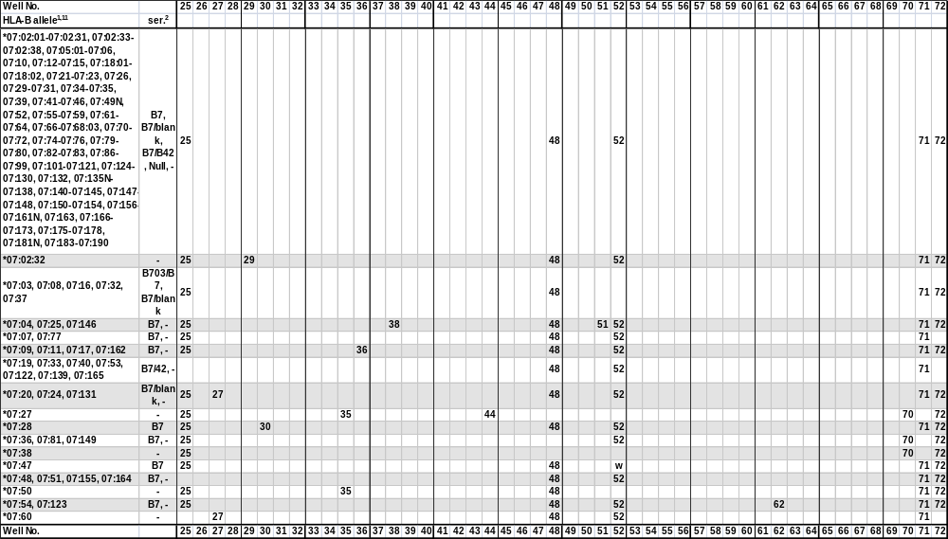
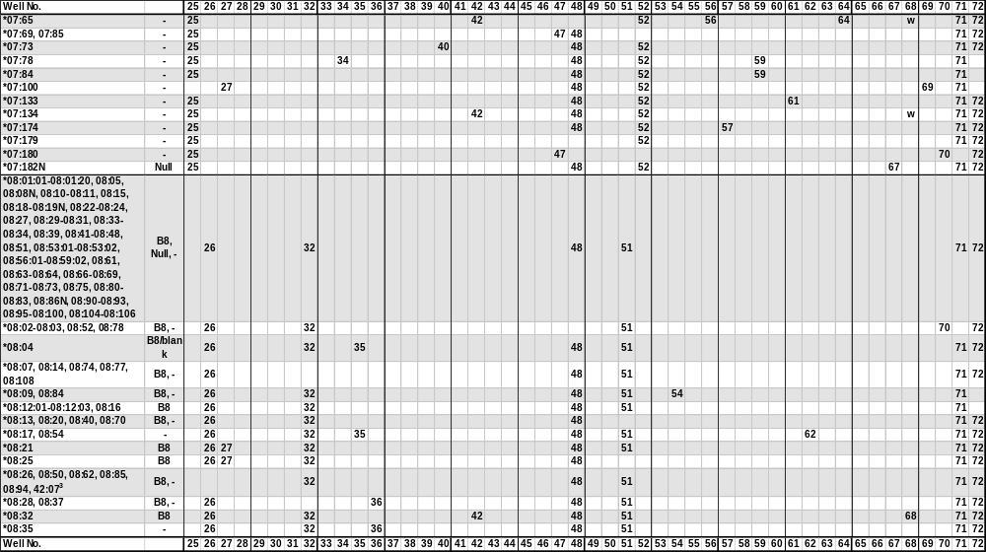
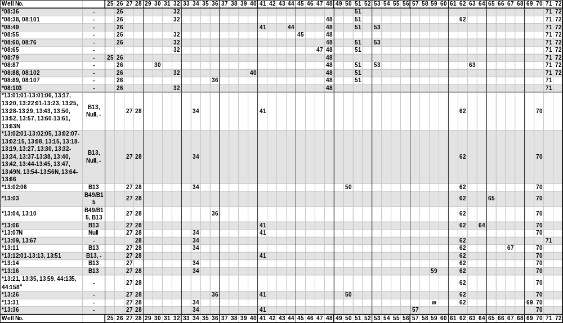
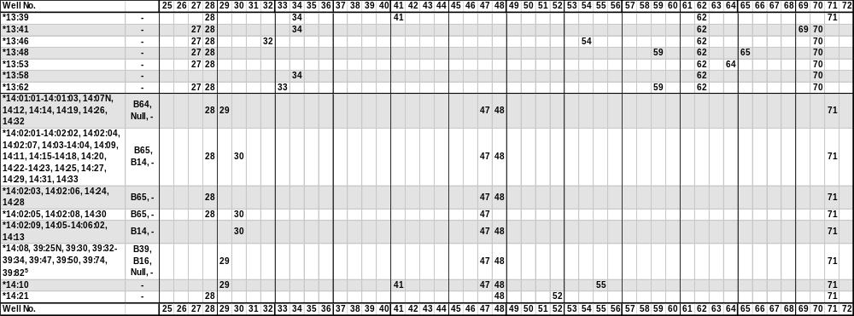
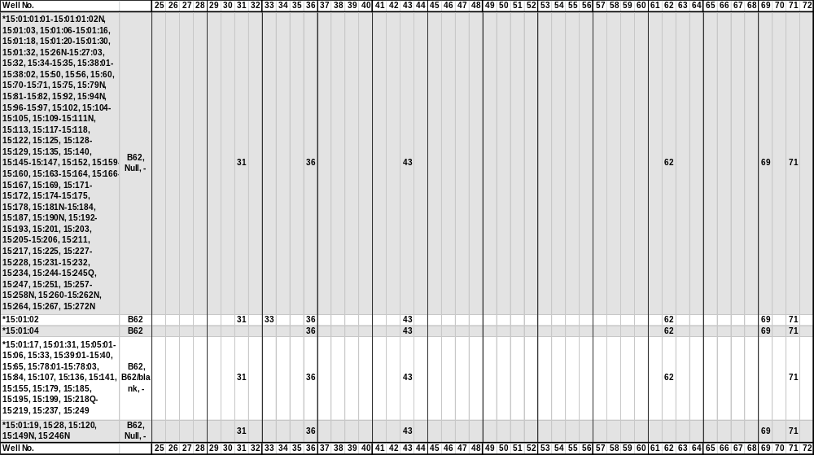
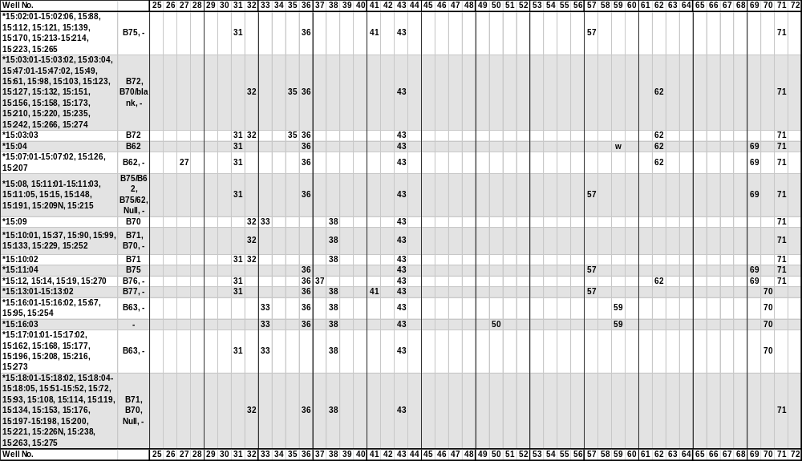
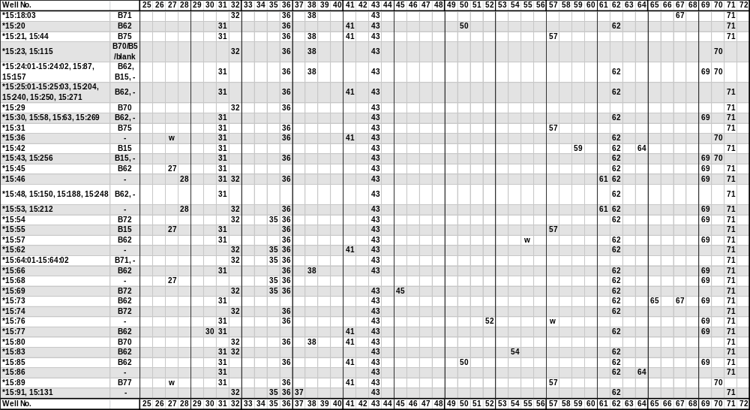
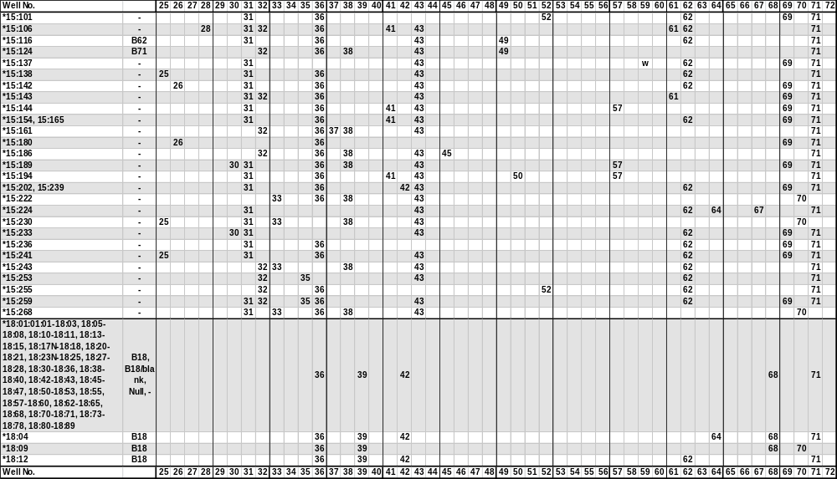
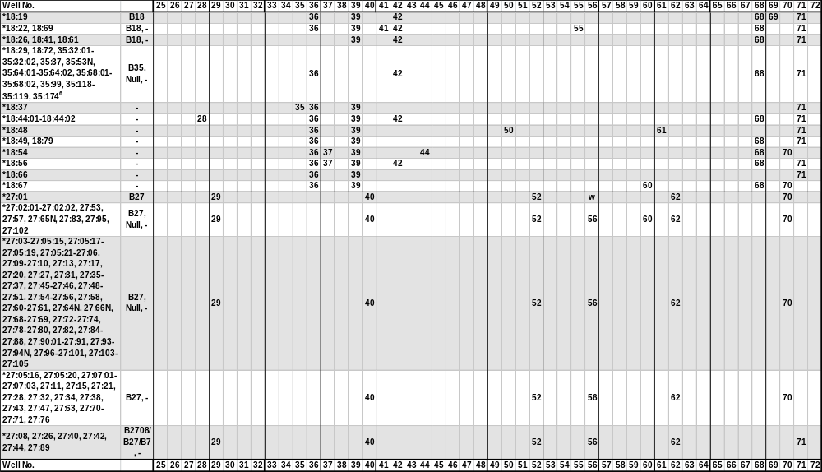
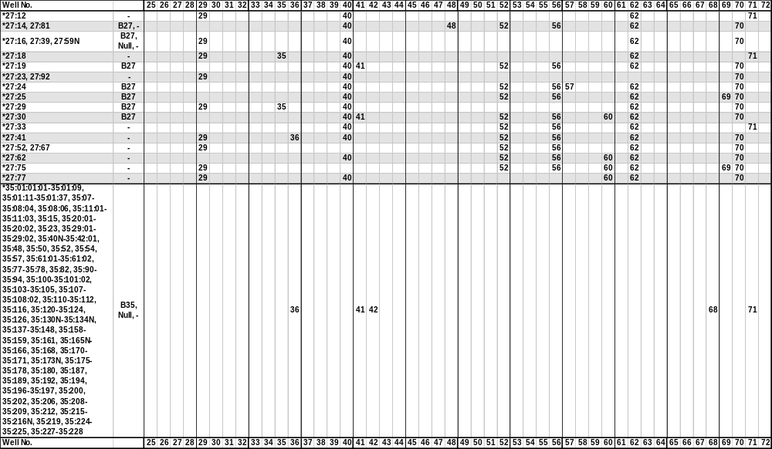
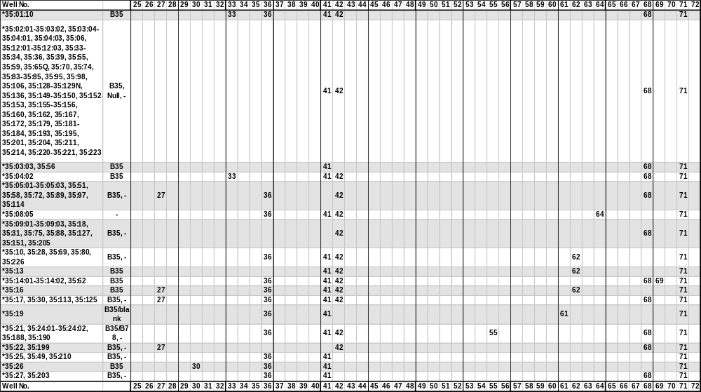
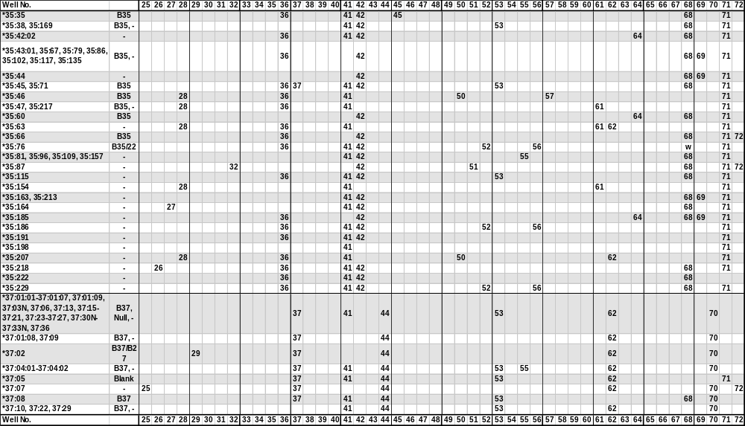
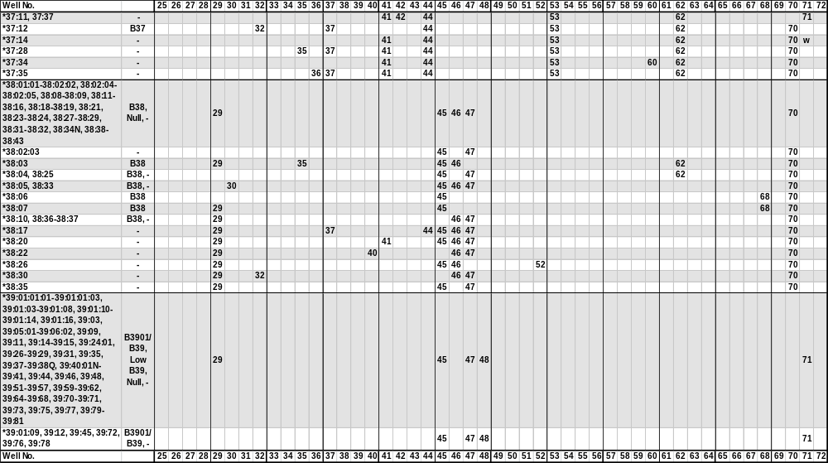
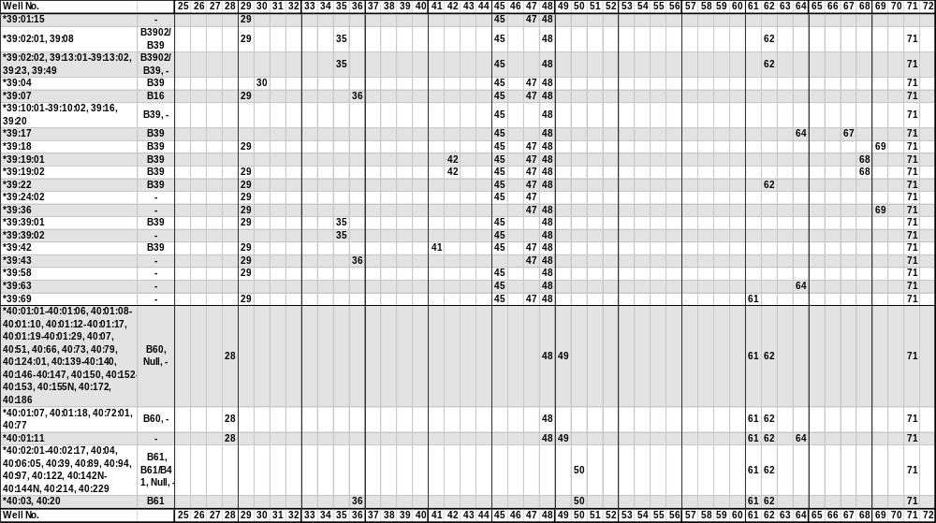
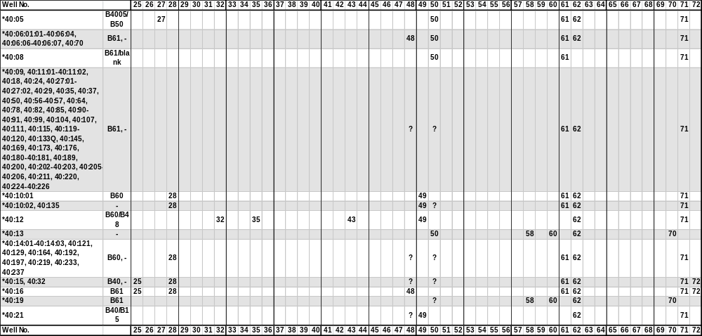
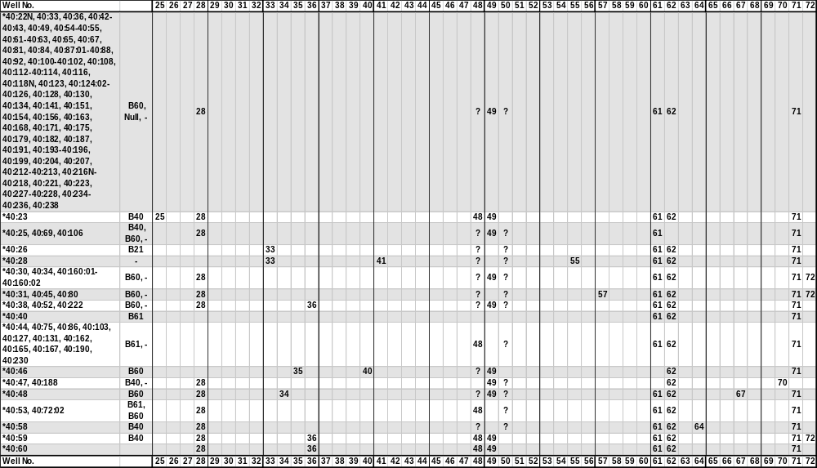
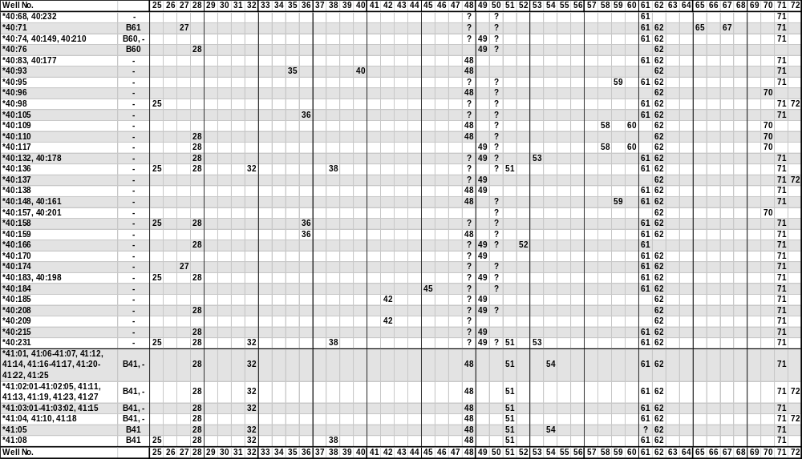
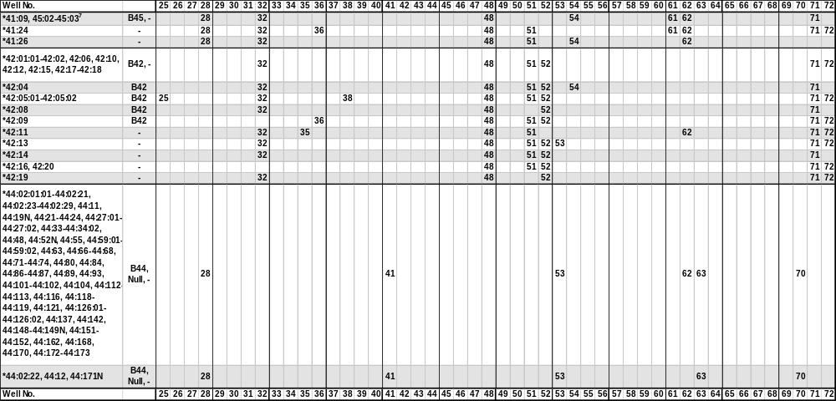
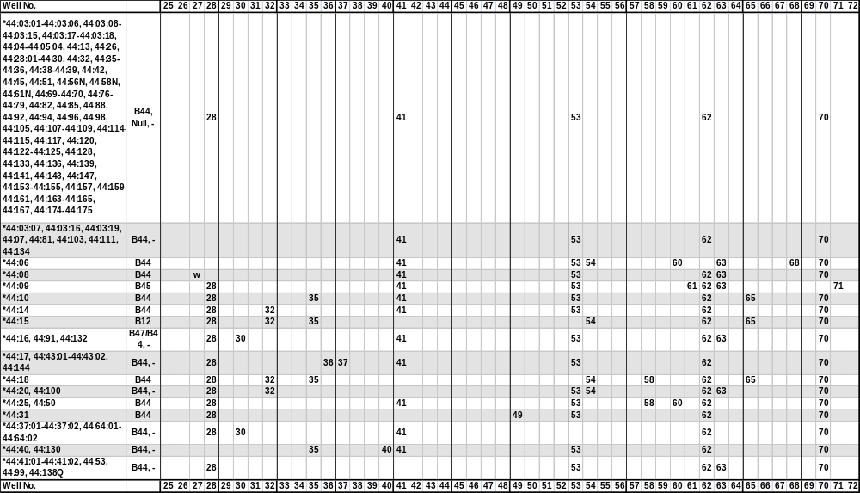
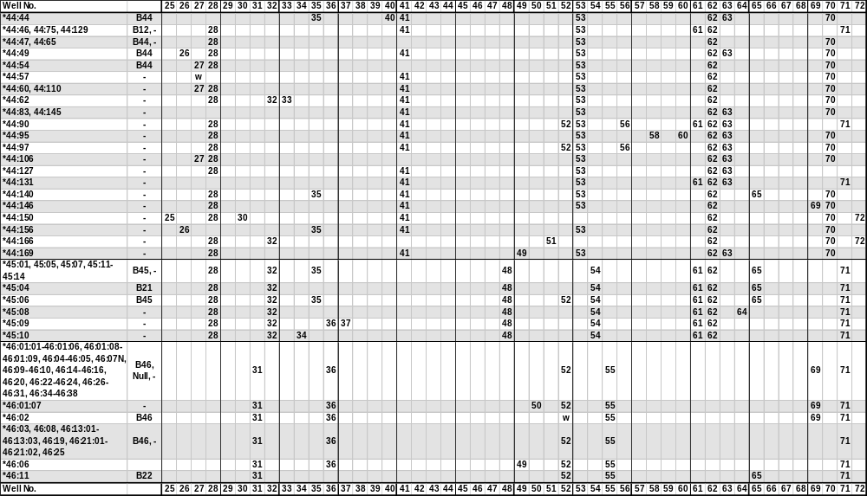
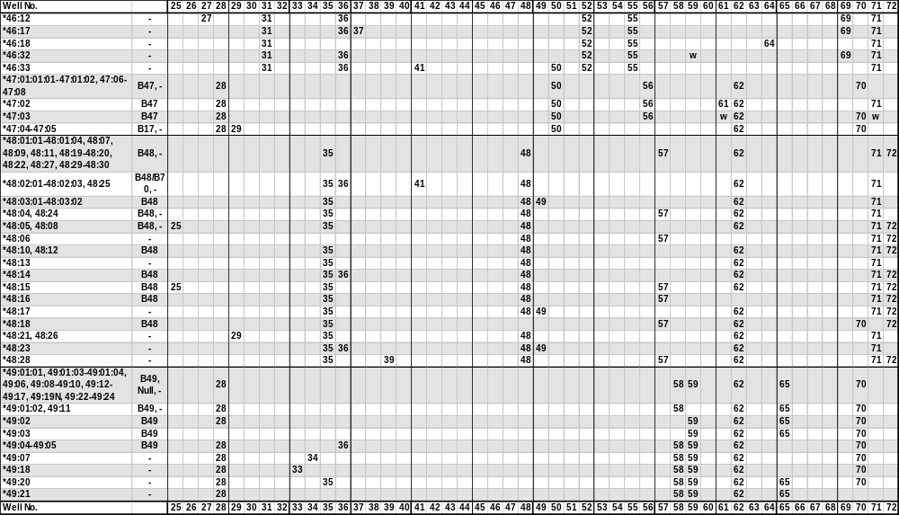
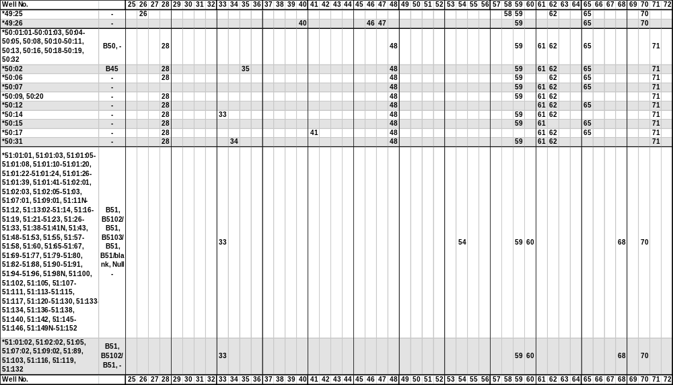
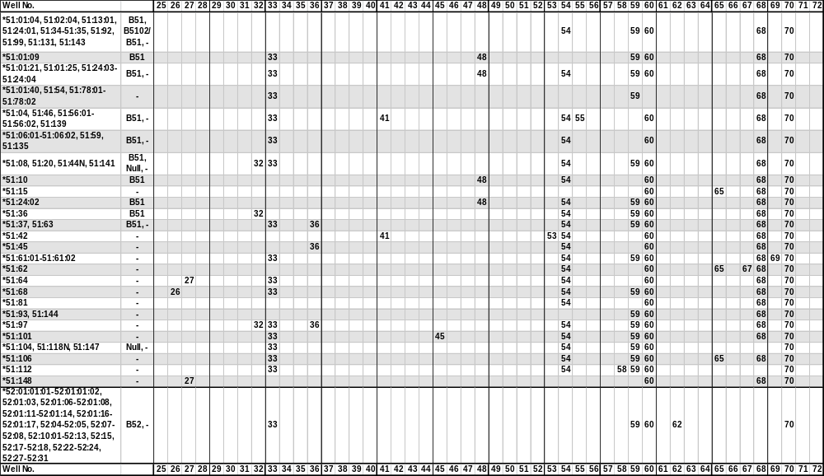
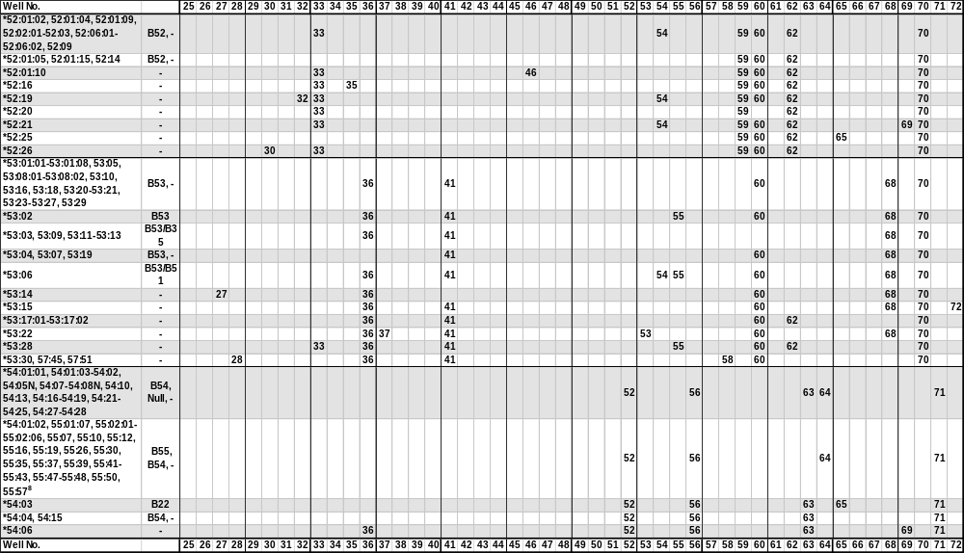
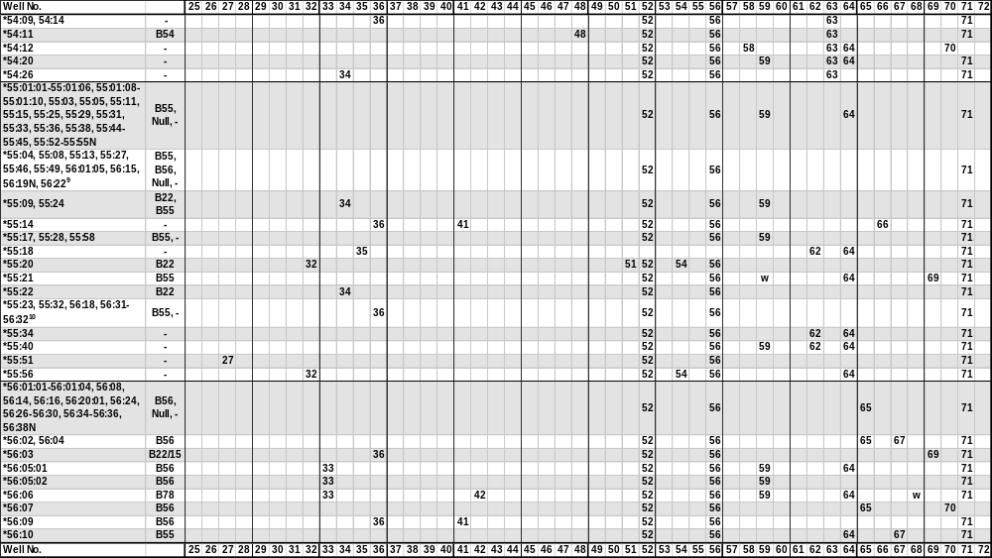
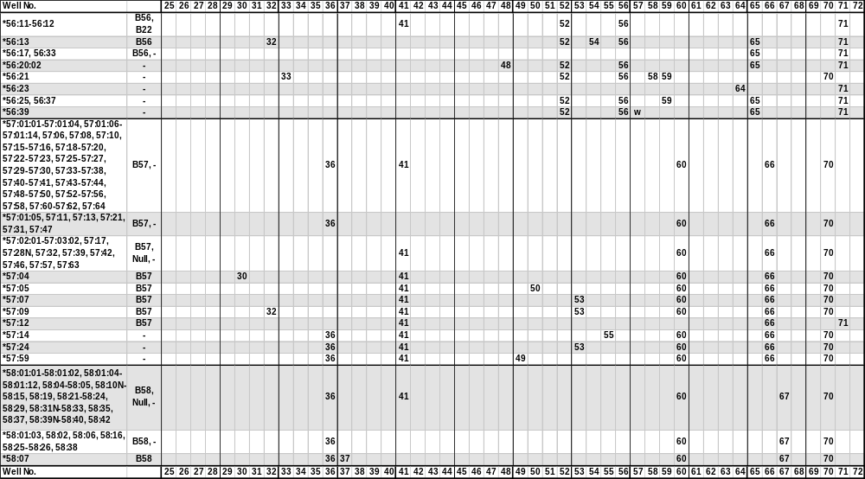
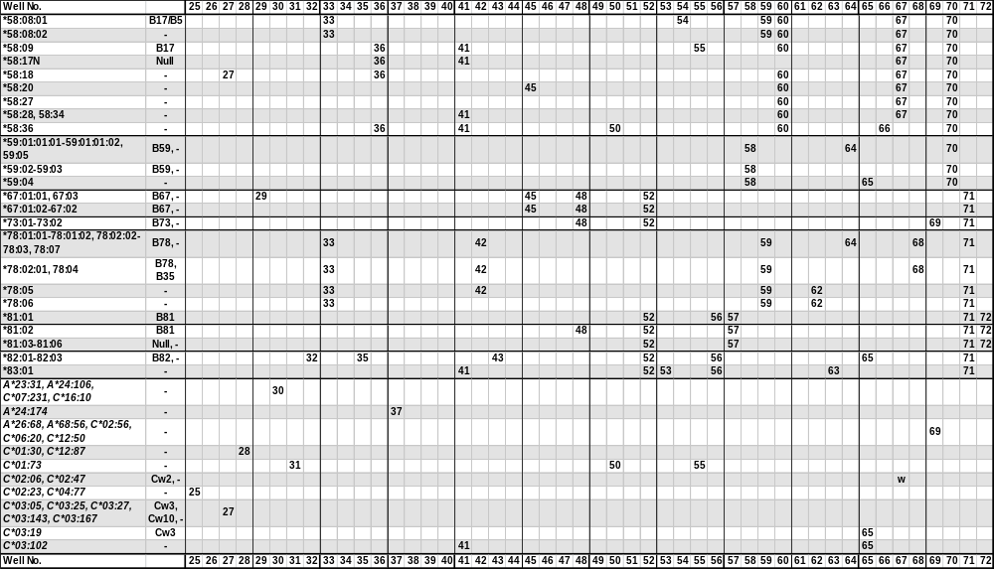
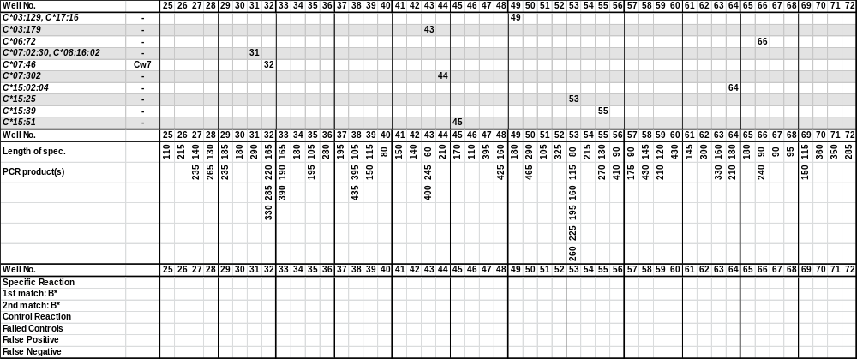
¹The sequence of the B*0701 allele has been shown to be in error.
The sequence of the B*08:06 allele has been shown to be identical to B*08:20.
The sequence of the B*1305 allele has been shown to be identical to B*13:04.
The B*1324 allele has been renamed B*13:22:02
The B*150105 allele has been corrected and renamed B*15:120
The B*1522 allele has been renamed B*35:43.
The sequence of the B*1541 allele has been shown to be identical to B*15:39.
The B*1559 allele has been renamed B*35:44.
The B*15:100 allele has never been assigned.
The sequence of the B*1816 allele has been shown to be identical to B*18:14.
The sequence of the B*27051 allele has been shown to be identical to B*27:05:02.
The sequence of the B*2722 allele has been shown to be identical to the corrected B*27:06 sequence.
The B*3573 allele has been renamed B*35:08:03.
The B*35:43:02 allele has been renamed B*35:185.
The sequence of the B*39012 allele has been shown to be identical to B*39:01:01:01.
The sequence of the B*3921 allele has been shown to be identical to B*39:24.
The sequence of the B*4017 allele has been shown to be identical to B*40:16.
The sequence of the B*4041 allele has been shown to be identical to B*40:40.
The sequence of the B*4203 allele has never been assigned.
The sequence of the B*4401 allele has been shown to be identical to B*44:02:01:01.
The sequence of the B*5003 allele has been shown to be identical to B*50:02.
The sequence of the B*5125 allele has been shown to be identical to B*51:22.
The B*5147 allele has been renamed B*51:09:02.
The sequence of the B*5506 allele has been shown to be identical to B*55:04.
The sequence of the B*5803 allele has never been assigned.
The sequence of the B*58:30 allele has been shown to be identical to B*58:01:01.
The B*7901 allele has been renamed B*15:18:01.
The B*9530 allele has been renamed B*15:27:02.
²The serological reactivity of all HLA-B alleles is not known. In this table we use the expert-assigned serological grouping in Tissue Antigens (2009) 73:95-170 and the serological grouping of the sequence-defined allele.
³The B*08:26, 08:50, 08:62, 08:85, 08:94 and 42:07 alleles give rise to identical amplification patterns with the HLA-B low resolution primer set. These alleles can be separated by the respective high resolution primer sets.
⁴The B*13:21, 13:35 and 13:59 and the B*44:135 and 44:158 alleles give rise to identical amplification patterns with the HLA-B low resolution primer set. These alleles can be separated by the respective high resolution primer sets.
⁵The B*14:08 and the B*39:25N, 39:30, 39:32-39:34, 39:47, 39:50, 39:74 and 39:82 alleles give rise to identical amplification patterns with the HLA-B low resolution primer set. These alleles can be separated by the respective high resolution primer sets.
⁶The B*18:29 and 18:72 and the B*35:32:01-35:32:02, 35:37, 35:53N, 35:64:01-35:64:02, 35:68:01-35:68:02, 35:99, 35:118-35:119 and 35:174 alleles give rise to identical amplification patterns with the HLA-B low resolution primer set. These alleles can be separated by the respective high resolution primer sets.
⁷The B*41:09 and the B*45:02-45:03 alleles give rise to identical amplification patterns with the HLA-B low resolution primer set. These alleles can be separated by the respective high resolution primer sets.
⁸The B*54:01:02 and the B*55:01:07, 55:02:01-55:02:06, 55:07, 55:10, 55:12, 55:16, 55:19, 55:26, 55:30, 55:35, 55:37, 55:39, 55:41-55:43, 55:47-55:48, 55:50 and 55:57 alleles give rise to identical amplification patterns with the HLA-B low resolution primer set. These alleles can be separated by the respective high resolution primer sets.
⁹The B*55:04, 55:08, 55:13, 55:27, 55:46, 55:49, 56:15, 56:19N, 56:22 alleles give rise to identical amplification patterns with the HLA-B low resolution primer set. These alleles can be separated by the respective high resolution primer sets.
¹⁰The B*55:23 and 55:32 and the B*56:18 and 56:31-56:32 alleles give rise to identical amplification patterns with the HLA-B low resolution primer set. These alleles can be separated by the respective high resolution primer sets.
¹¹Primer mix 28 amplifies the B*15:143, 35:19, 40:170, 44:07 and 50:07 alleles, and primer mix 50 amplifies the B*37:06:01 allele in addition to the alleles specified in the tables.
‘ser’, serological HLA specificity.
‘w’, might be weakly amplified.
‘?’, nucleotide sequence information not available for the primer matching sequence.
Specificities and sizes of the PCR products of the 23+1 primer mixes used for DR low resolution SSP typing.

Primer Mix | Size of spec. PCR product¹ | Size of control band² | DR  serology³ | Amplified HLA-DRB alleles^{4,5}
73^{7,8} | 205 bp,  255 bp | 515 bp | 1 | *01:01:01-01:02:08, 01:04-01:38, 01:40N-01:58
74 | 200 bp | 430 bp | 103 | *01:03, 01:39N, 01:42
75⁷ | 200 bp,  220 bp | 430 bp | 15 | *15:01:01:01-15:94
76 | 210 bp | 430 bp | 16 | *16:01:01-16:05:02, 16:07-16:23
77^{5,6,7} | 120 bp,  220 bp | 430 bp | 3, 17, 18, 11 | *03:01:01:01-03:75, 03:77-03:84, 03:86-03:90, 11:07, 11:53, 11:103, 11:105, 11:107, 11:125, 15:25
78^{5,6,7} | 80 bp,  210 bp | 430 bp | 3, 17, 11, 13, 14,6 | *03:01:01:01-03:01:22, 03:04:01-03:06, 03:08-03:16, 03:18-03:20, 03:22-03:23, 03:25-03:26, 03:28, 03:30-03:31, 03:33-03:34, 03:36-03:37, 03:43-03:48, 03:50-03:52, 03:54-03:68N, 03:70-03:73, 03:75-03:84, 03:86, 03:89, 08:40, 11:02:01-11:03, 11:11:01-11:11:02, 11:14:01-11:14:02, 11:16, 11:20-11:21, 11:36, 11:40-11:41, 11:48, 11:59, 11:63, 11:65:01-11:65:02, 11:68, 11:70, 11:73, 11:76, 11:79-11:80, 11:83, 11:85-11:87, 11:93, 11:118, 11:122, 11:124, 11:127, 11:131-11:132, 11:135, 11:138-11:139, 11:142, 13:01:01-13:04, 13:08, 13:10, 13:15-13:17, 13:19-13:20, 13:22-13:24, 13:27-13:29, 13:31-13:41, 13:43, 13:45, 13:48, 13:51-13:54, 13:57, 13:59, 13:61:01-13:61:02, 13:63-13:66:02, 13:68-13:76, 13:78-13:81, 13:83-13:85, 13:87-13:99, 13:101-13:102, 13:104-13:107, 13:109, 13:111-13:117, 13:120-13:131, 13:133, 13:135, 13:137N-13:145, 13:147-13:149, 13:151-13:153, 13:155, 13:159, 14:16, 14:19, 14:21, 14:82, 14:95, 14:109, 14:132, 14:137N
79^{6,7} | 85 bp,  210 bp | 430 bp | 3, 18, 11, 13, 14,6 | *03:02:01-03:03, 03:27, 03:29, 03:38, 03:53, 03:74, 03:88, 03:90, 11:13:01^{w}-11:13:02^{w}, 11:26, 11:34, 13:15, 13:19, 13:26:01-13:26:02, 13:44, 13:53, 13:57, 13:85-13:86, 13:104, 14:02-14:03:02, 14:06:01-14:06:02, 14:09, 14:12:01-14:13, 14:17-14:21, 14:24, 14:27, 14:29-14:30, 14:32:01^{w}-14:32:02^{w}, 14:33, 14:40-14:41, 14:47-14:49, 14:51, 14:63, 14:65^{w}, 14:67, 14:77-14:78, 14:80-14:81, 14:83, 14:85, 14:89, 14:94, 14:98, 14:102, 14:106, 14:108-14:109, 14:115, 14:119, 14:121, 14:135
80^{6,7,8} | 100 bp,  175 bp | 430 bp | 3,4 | *04:01:01-04:05:11, 04:05:13-04:158N
81⁷ | 210 bp,  235 bp | 430 bp | 7, 13, 14 | *07:01:01:01-07:01:04, 07:03-07:24, 12:22, 13:17, 13:116, 14:50
82⁷ | 170 bp,  215 bp,  250 bp | 515 bp | 8, 12, 14 | *08:01:01-08:19, 08:21-08:53, 11:67, 12:04, 12:16:01-12:16:02, 12:22, 12:39, 14:11, 14:15, 14:68, 14:93
83^{6,7} | 90 bp,  135 bp,  180 bp | 430 bp | 3, 9, 11 | *03:08, 03:65, 09:01:02-09:20, 11:07, 11:53, 11:103, 11:105, 11:107, 11:125
84 | 175 bp | 430 bp | 10,11,13 | *03:76, 10:01:01-10:05, 11:59, 11:80, 11:83, 11:87, 11:135, 11:142, 13:27, 13:41, 13:71, 13:129
85^{6,7} | 100 bp,  170 bp | 430 bp | 11, 3, 8 | *03:08, 03:65, 08:31, 08:41, 11:01:01-11:70, 11:72-11:145
86^{6,7} | 85 bp,  105 bp | 430 bp | 12, 8 | *08:32, 08:53, 12:01:01-12:39
87⁸ | 215 bp | 430 bp | 6, 8, 11, 13, 14, 1403 | *03:76, 08:20-08:21, 11:01:01-11:04:11, 11:06:01-11:06:03, 11:08:01-11:12:02, 11:14:01-11:16, 11:18-11:21, 11:23-11:25, 11:27:01-11:33, 11:35-11:51, 11:54:01-11:54:02, 11:56-11:66, 11:68, 11:70, 11:72-11:81, 11:83-11:88, 11:90-11:97, 11:99-11:102:02, 11:106, 11:108-11:124, 11:126-11:135, 11:137-11:142, 11:144-11:145, 13:01:01-13:02:01, 13:02:03-13:08, 13:10-13:16, 13:18-13:43, 13:45-13:85, 13:87-13:115, 13:117-13:128, 13:130-13:145, 13:147-13:161, 14:03:01-14:03:02, 14:12:01-14:12:02, 14:16, 14:19, 14:21-14:22, 14:25, 14:27, 14:40, 14:53, 14:63, 14:67, 14:69, 14:74, 14:77-14:78, 14:84-14:85, 14:98, 14:102, 14:105, 14:109, 14:115-14:116, 14:128, 14:135, 14:137N, DRB3*02:27
88^{7,8} | 195 bp, 225bp | 430 bp | 13, 8, 11, 12, 14, 6 | *08:01:01-08:02:04, 08:04:01-08:09, 08:11, 08:16-08:17, 08:20-08:22, 08:24, 08:26, 08:28, 08:31, 08:39, 08:41-08:44, 08:50, 08:52, 11:01:01-11:01:17, 11:02:01-11:06:03, 11:09-11:12:02, 11:14:01-11:16, 11:20-11:21, 11:23-11:25, 11:27:01-11:30, 11:32-11:33, 11:35-11:41, 11:43-11:44, 11:46:01-11:51, 11:54:01-11:56, 11:58:01-11:63, 11:65:01-11:70, 11:72, 11:74:01-11:78, 11:80-11:88, 11:90-11:97, 11:99-11:102:02, 11:106, 11:108-11:118, 11:120-11:124, 11:126-11:129, 11:133-11:135, 11:137-11:142, 11:144-11:145, 12:02:01-12:02:05, 12:13, 12:15-12:16:02, 12:18-12:21, 12:23, 12:26-12:27, 12:31N-12:33, 12:37, 13:01:01-13:02:01, 13:02:03-13:02:08, 13:04-13:05:02, 13:07:01-13:09, 13:11:01-13:11:02, 13:14:01-13:24, 13:26:01-13:29, 13:31-13:32, 13:34-13:36, 13:38-13:43, 13:45-13:55, 13:57, 13:59, 13:61:01-13:65, 13:67-13:76, 13:78-13:80, 13:83-13:84, 13:87, 13:91-13:93, 13:96:01-13:100, 13:102-13:109, 13:111-13:114, 13:116-13:117, 13:121, 13:123-13:132, 13:135-13:136, 13:138-13:150, 13:153, 13:155, 13:158-13:160, 14:15-14:16, 14:22, 14:24-14:25, 14:27, 14:37, 14:53, 14:73, 14:105, 14:128
89⁵ | 175 bp | 430 bp | 3, 13, 14, 17, 6, 11 | *03:01:01:01-03:07, 03:09, 03:11:01-03:41, 03:43-03:45, 03:47-03:63, 03:66-03:68N, 03:70-03:84, 03:86, 03:88-03:90, 08:20, 13:01:01-13:16, 13:18-13:42, 13:44, 13:46-13:66:02, 13:68-13:102, 13:104-13:115, 13:117-13:121, 13:123-13:158, 13:161, 14:02-14:03:02, 14:05:01-14:06:02, 14:09, 14:12:01-14:14, 14:17-14:21, 14:23:01, 14:23:03-14:24, 14:27, 14:29-14:30, 14:33, 14:36-14:37, 14:40-14:45, 14:47-14:48, 14:51, 14:56, 14:59, 14:63-14:65, 14:67, 14:77-14:78, 14:80-14:81, 14:83-14:85, 14:89, 14:91, 14:94-14:96, 14:98, 14:100, 14:102-14:103, 14:106, 14:108-14:109, 14:115-14:116, 14:121, 14:123, 14:127:01-14:127:02, 14:134-14:136
90^{6,7} | 100 bp,  140 bp,  155 bp, | 430 bp | 14, 4, 8,13, 6 | *04:62, 04:69, 04:73, 04:105:01-04:105:02, 04:122, 04:146, 08:08, 11:69, 11:82, 13:45, 14:01:01-14:01:02, 14:01:04, 14:04, 14:07:01-14:07:02, 14:10, 14:16, 14:22, 14:25-14:26, 14:28, 14:31-14:32:03, 14:35, 14:37-14:39, 14:49-14:50, 14:53-14:54:01, 14:55, 14:57-14:58, 14:60-14:62, 14:68-14:71, 14:73-14:76, 14:79, 14:82, 14:86-14:88, 14:90, 14:93, 14:99, 14:101, 14:104-14:105, 14:107, 14:110-14:114, 14:117-14:120, 14:122, 14:124-14:125, 14:128-14:129, 14:131, 14:137N-14:140, DRB4*01:03:01:02N
91^{6,7,9} | 110 bp,  135 bp,  170 bp | 430 bp | 14, 3, 9, 11, 12, 13, 15, 6, 4 | *03:10, 09:01:02-09:01:05, 09:01:07-09:02:02, 09:04-09:20, 11:13:01-11:13:02, 11:17, 11:52, 13:43, 13:159, 14:01:01-14:02, 14:04-14:11, 14:13-14:14, 14:16-14:18, 14:19^{w}, 14:20, 14:21^{w}, 14:22-14:23:04, 14:26, 14:28-14:36, 14:38-14:39, 14:41, 14:43-14:52, 14:54:01-14:57, 14:59-14:62, 14:64-14:65, 14:68, 14:70-14:76, 14:79-14:83, 14:86-14:88, 14:90-14:97, 14:99-14:101, 14:103-14:108, 14:109^{w}, 14:110-14:114, 14:117-14:127:02, 14:129-14:134, 14:137N-14:140, 15:27, 15:34, 15:66
92^{6,7,8} | 110 bp,  175 bp,  225 bp | 430 bp | 14, 3, 8, 11, 13, 15, 16, 6, 2 | *03:10, 08:09, 08:20-08:21, 08:32, 08:35, 08:36:02, 08:53, 11:13:01-11:13:02, 11:17, 11:23, 11:25, 11:31, 11:45, 11:52, 11:55, 11:64, 11:89, 11:96, 11:119, 13:13, 13:18, 13:43, 13:45, 13:47, 13:55, 13:119, 13:144, 13:146, 13:154, 13:156, 13:158-13:159, 14:01:01-14:01:04, 14:03:01-14:05:04, 14:07:01-14:08, 14:10-14:12:02, 14:14-14:16, 14:18, 14:22-14:23:04, 14:25-14:28, 14:31-14:32:03, 14:34-14:36, 14:38-14:40, 14:42-14:45, 14:49-14:50, 14:53-14:65, 14:67-14:79, 14:81-14:82, 14:84-14:93, 14:95-14:97, 14:99-14:105, 14:107, 14:110-14:120, 14:122-14:140, 15:21^{w}, 16:04^{w}, 16:18^{w}
93^{7,8} | 160 bp,  240 bp | 430 bp | 52 | DRB3*01:01:02:01-01:15, DRB3*02:01-02:29N, DRB3*03:01:01-03:03
94^{8,10} | 215 bp | 430 bp | 53 | DRB4*01:01:01:01-01:08
95 | 175 bp | 430 bp | 51 | DRB5*01:01:01-01:14, DRB5*02:02-02:06
96¹¹ |  |  |  | Negative control

¹Alleles are assigned by the presence of specific PCR product(s). However, the sizes of the specific PCR products may be helpful in the interpretation of DR low resolution SSP subtypings.
When the primers in a primer mix can give rise to HLA-specific PCR products of more than one length this is indicated if the size difference is more than 20 base pairs. Size differences of 20 base pairs or less are not given. For high resolution SSP kits the respective lengths of the HLA-specific PCR product(s) are given for the alleles amplified by these primer mixes.
Nonspecific amplifications, i.e. a ladder or a smear of bands, may sometimes be seen. GC-rich primers have a higher tendency of giving rise to nonspecific amplifications than other primers, e.g. the primers in wells 75 and 90 to 92.
PCR fragments longer than the control bands may sometimes be observed. Such bands should be disregarded and do not influence the interpretation of the SSP typings.
PCR fragments migrating faster than the control bands, but slower than a 400 bp fragment may be seen in some gel read-outs. Such bands can be disregarded and do not influence the interpretation of the SSP typings.
Some primers may give rise to primer oligomer artifacts. Sometimes this phenomenon is an inherit feature of the primer pair(s) of a primer mix. More often it is due to other factors such as too low amount of DNA in the PCR reactions, taking too long time in setting up the PCR reactions, working at elevated room temperature or using thermal cyclers that are not pre-heated.
²The internal positive control primer pairs amplify segments of the human growth hormone gene. The two different control primer pairs give rise to either an internal positive control band of 430 base pairs, for most wells, or a band of 515 base pairs, for some wells.
Well number 73 contains the primer pair giving rise to the longer, 515 bp, internal positive control band.
In addition, well number 82 contains the primer pair giving rise to the longer, 515 bp, internal positive control band.
In the presence of a specific amplification the intensity of the control band often decreases.
³The serological split of all DRB1 alleles is not known. In this table we use the expert-assigned serological grouping in Tissue Antigens (2009) 73:95-170 and the serological grouping of the sequence-defined allele.
⁴For several DRB alleles 1st and/or 3rd exon(s) and beyond, as well as intron nucleotide sequences, are not available. In these instances it is not known whether some of the primers of the SSP set are completely matched with the target sequences or not. We assume that unknown sequences in the first hyperpolymorphic region of the second exon of DRB alleles are conserved within allelic groups and that unknown sequences of codons 87 to 92 are identical with the DRB1*01:01 consensus sequence.
⁵Due to sharing of sequence motifs in codon 38, DRB3*01:14 will also be amplified in primer mixes 77, 78 and 89 in addition to primer mix 93.
⁶HLA-specific PCR products shorter than 125 base pairs have a lower intensity and are less sharp than longer PCR products.
⁷Individual alleles can give to rise to two differently sized specific PCR fragments in primer mixes 73, 75, 77 to 83, 85, 86, 88 and 90 to 93.
⁸Primer mix 73, 80, 87, 88 and 92 to 94 may have a tendency to giving rise to primer oligomer formation.
⁹Primer mix 91 has a tendency of primer oligomer formation and also has an intense primer cloud due to the high number of primers present in the primer mix.
¹⁰The DRB4*01:03:01:02N allele is amplified by primer mix 94, whereas the DRB4*02:01N and DRB4*03:01N null alleles are not amplified by this primer mix.
¹¹Primer mix 96 contains a negative control, which will amplify more than 95% of HLA amplicons as well as the amplicons generated by control primer pairs. PCR product sizes range from 75 to 200 base pairs. The PCR product generated by the control primer pair is 430 base pairs.
‘w’, might be weakly amplified.

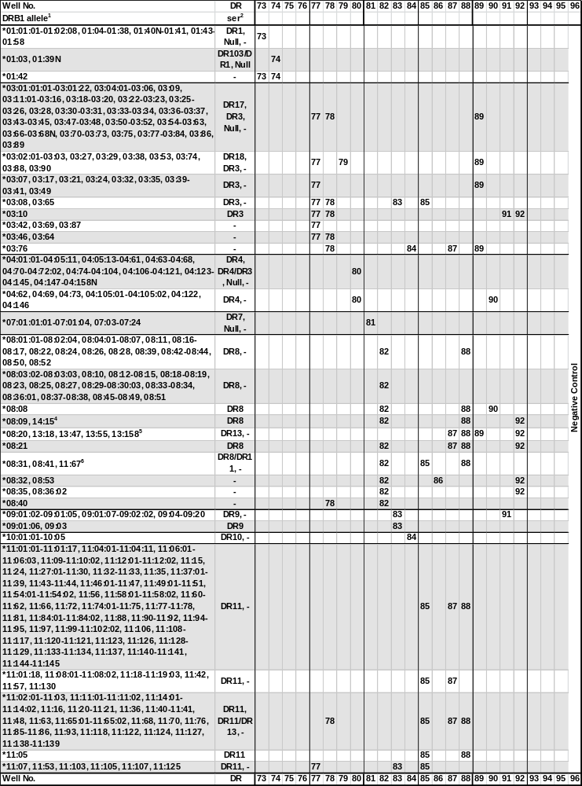
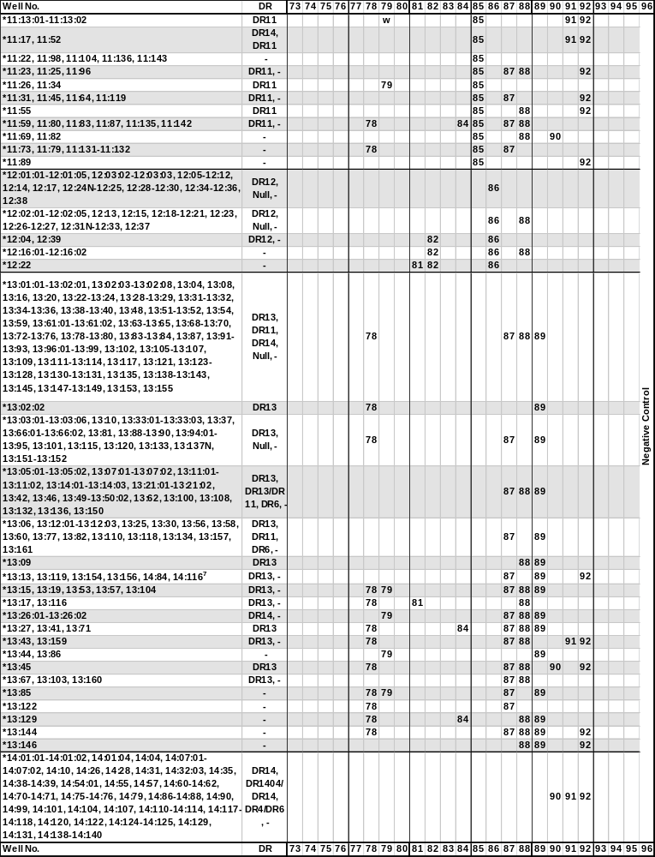
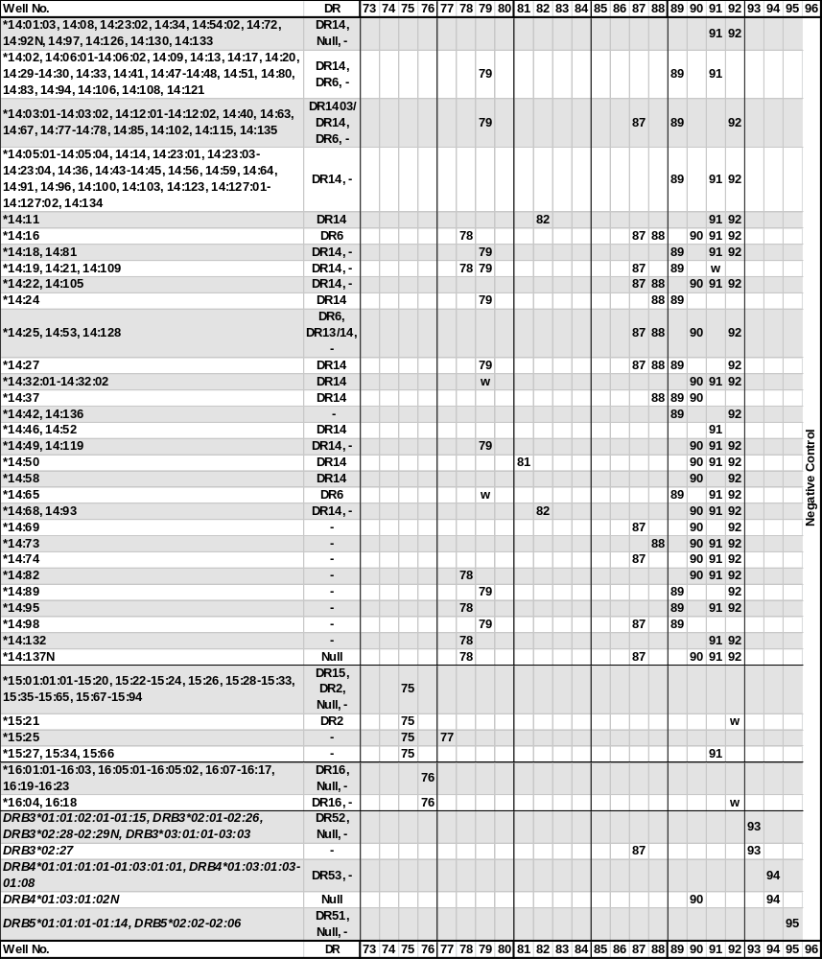

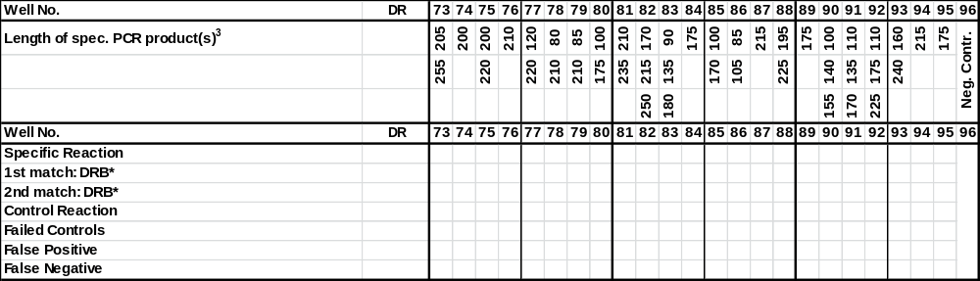

¹The DRB1*03:11:02 allele has been renamed DRB1*03:81.
The sequence of the DRB1*04:05:12 allele has been shown to be identical to DRB1*04:05:14.
The sequence of the DRB1*0702 allele has been shown to be identical to DRB1*07:01:01:01.
The sequence of the DRB1*080301 allele has been shown to be identical to DRB1*08:03:02.
The sequence of the DRB1*09011 allele has been shown to be identical to DRB1*09:01:02.
The sequence of the DRB1*1171 allele has been shown to be identical to DRB1*11:02:01.
The sequence of the DRB1*12031 allele has been shown to be identical to DRB1*12:01:01.
The DRB1*1466 allele has been renamed DRB1*14:32:02.
The sequence of the DRB1*1606 allele has been shown to be identical to DRB1*16:05:01.
The sequence of the DRB3*010101 allele has been shown to be identical to DRB3*01:01:02:01.
The DRB4*0101102N allele has been renamed DRB4*01:03:10:02N.
The sequence of the DRB5*0201 allele has been shown to be identical to DRB5*02:02.
Due to sharing of sequence motifs in codon 38, DRB3*01:14 will also be amplified in primer mixes 77, 78 and 89 in addition to primer mix 93.
The DRB4*02:01N and DRB4*03:01N null alleles will not be amplified by the DR low resolution primer set.
²The serological reactivity of all DRB alleles is not known. In this table we use the expert-assigned serological grouping in Tissue Antigens (2009) 73:95-170 and the serological grouping of the sequence-defined allele.
³Primer mix 96 contains a negative control, which will amplify more than 95% of HLA amplicons as well as the amplicons generated by control primer pairs. PCR product sizes range from 75 to 200 base pairs. The PCR product generated by the control primer pair is 430 base pairs.
⁴The DRB1*08:09 and the DRB1*14:15 alleles yield identical amplification patterns with the DR low resolution primer set. These alleles can be separated by the respective high resolution primer sets.
⁵The DRB1*08:20 and the DRB1*13:18, 13:47, 13:55 and 13:158 alleles yield identical amplification patterns with the DR low resolution primer set. These alleles can be separated by the respective high resolution primer sets.
⁶The DRB1*08:31, 08:41 and DRB1*11:67 alleles yield identical amplification patterns with the DR low resolution primer set. These alleles can be separated by the respective high resolution primer sets.
⁷The DRB1*13:13, 13:119, 13:154 and 13:156 and the DRB1*14:84 and 14:116 alleles yield identical amplification patterns with the DR low resolution primer set. These alleles can be separated by the respective high resolution primer sets.
‘ser’, serological HLA specificity.
‘w’, may be weakly amplified.

Changes in revision R01 compared to R00:
- Primer mix 43 does not amplify the B*44:10 allele. This has been corrected in the Specificity and Interpretation Tables.
Change in revision R02 compared to R01:
- Primer mix 19 does not amplify the A*74:07 allele, and primer mix 11 does not amplify the A*31:03 and A*66:15 alleles. This has been corrected in the Specificity and Interpretation tables.
The A*32:01:14, 32:03, 32:38 and the A*74:07 alleles give rise to identical amplification patterns with this lot of the HLA-A low resolution primer set. These alleles can be separated by the respective high resolution primer sets.
Change in revision R03 compared to R02:
- Primer mix 28 amplifies the B*15:143, 35:19, 40:170, 44:07 and 50:07 alleles, and primer mix 50 amplifies the B*37:06:01 allele. Foot notes for these two primer mixes have been added to the Specificity Table.

